Reading at Home
In order to reduce the risk of transmitting the virus we have taken the decision not to send home reading books during the lockdown period. There are many books available online for your child to read, enjoy and use to develop their reading skills. Here is a short guide to using Oxford Owls in this way.
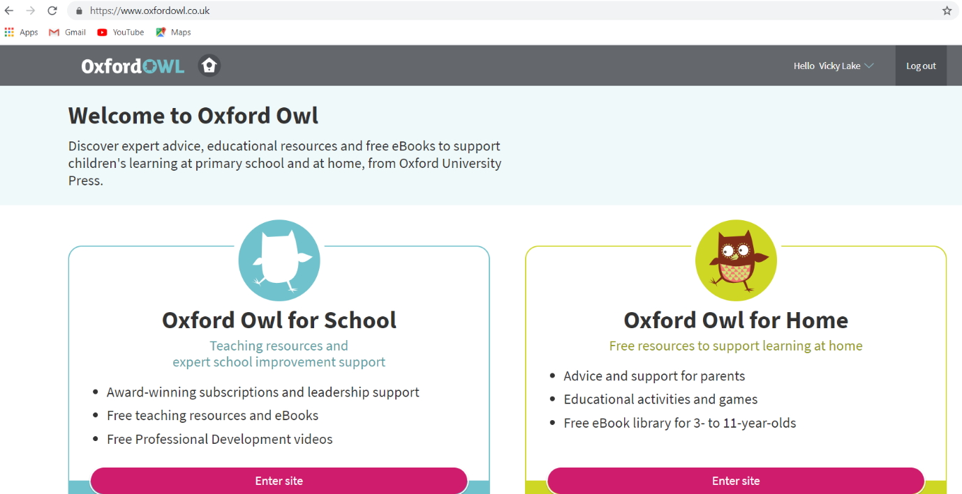
Visit www.oxfordowl.co.uk
Select Oxford Owl for Home.

Select ‘Browse eBooks’
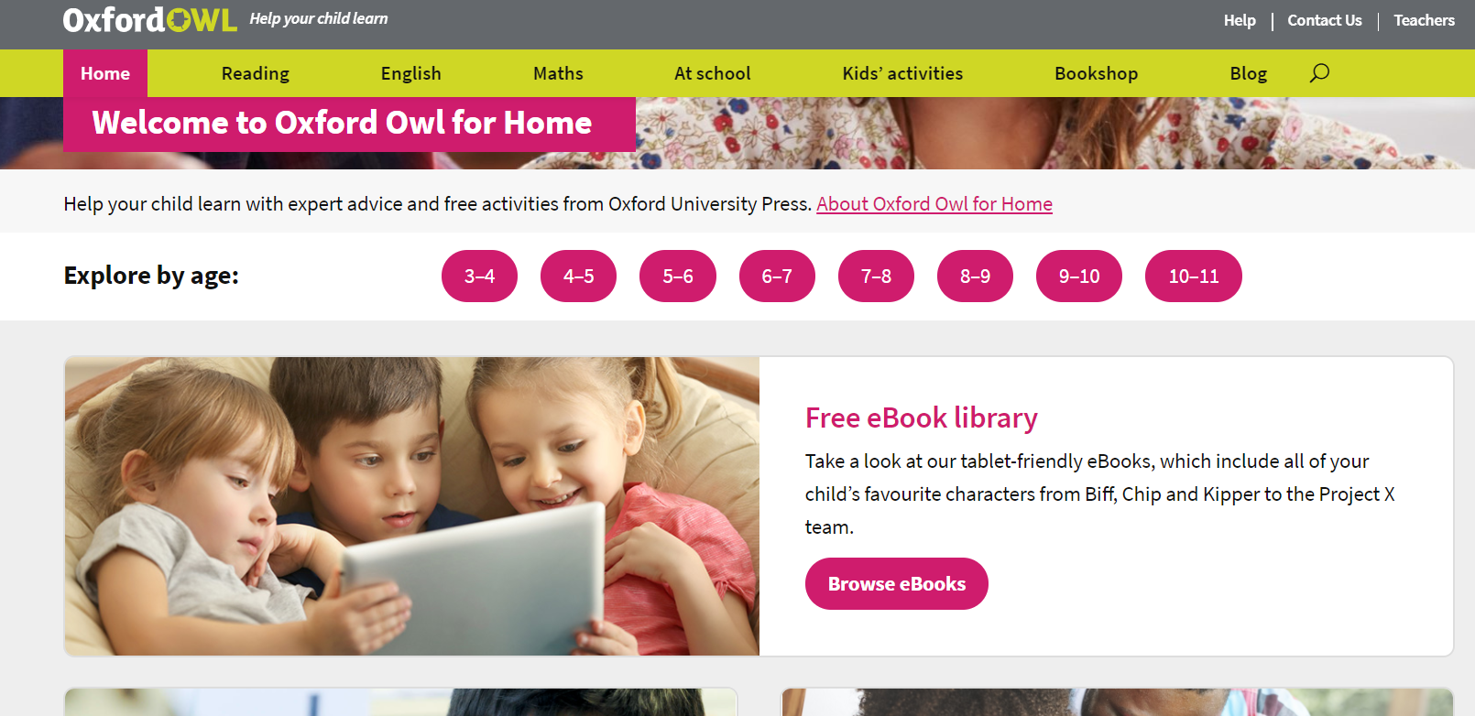

Select the correct Book Band colour for your child.
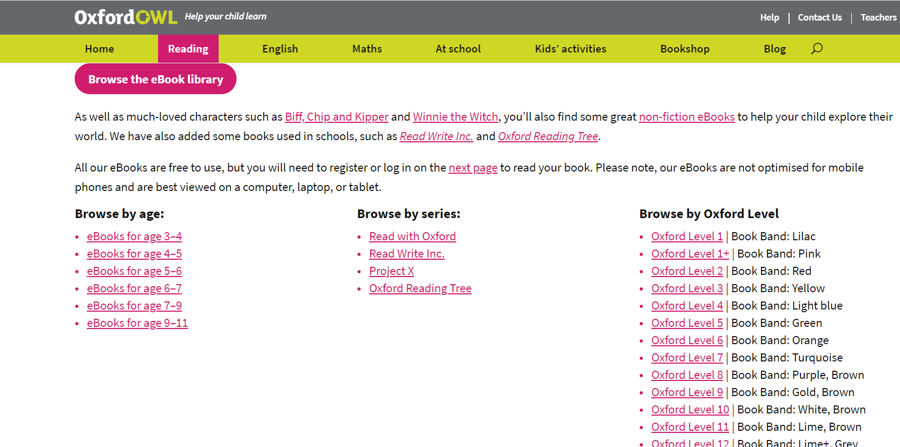
Complete the follow-up activities here.

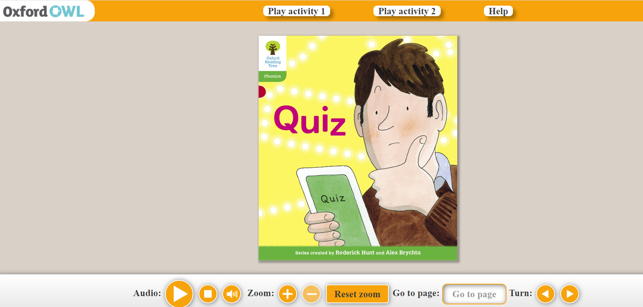
Turn the pages here.
Text can be read to you by pressing here.
There are other reading schemes available on here which you and your child can explore. If the text is too difficult on a book they want to read then you could read along with them or use the audio function.
There are other websites which offer eBooks for children including
www.getepic.com
www.amazon.co.uk
www.twinkl.co.uk
The cbeebies StoryTime app is very good for young children. https://www.bbc.co.uk/cbeebies/grownups/cbeebies-storytime-app

