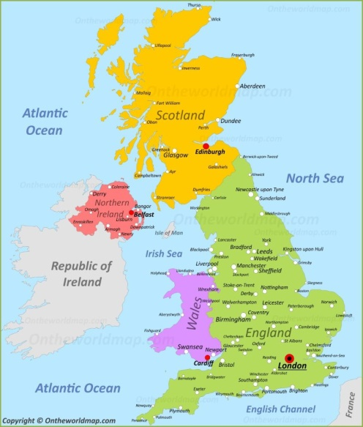**Homework Menu** - Year 1 and 2 (Summer Term- The UK)

Draw/Make the flags of Britain.

Bake a classic British recipe.

Create at least 6 ‘Did you know’ fact cards about the UK.

Create a fact-file poster about the UK.

Go for a walk around your local area and draw a map or take pictures to bring into class.

Make a model of a famous London building.

Make a model compass with moveable compass needle.

Collect leaflets/maps about the UK and our local area.

Choose a town or city within Britain and make a poster about it.

Go and explore, find something from a beach and something from the moors!

Read your reading book every night of the week- make sure you fill in your reading record.

Choose a fun way to write out your spellings.

Make your own clock (Year 1 and 2).

Use a paper plate or something similar draw a cake or a pizza then cut it into half and quarters. (Year 1)

Year 2 can you also do the same but make three-quarters in addition!

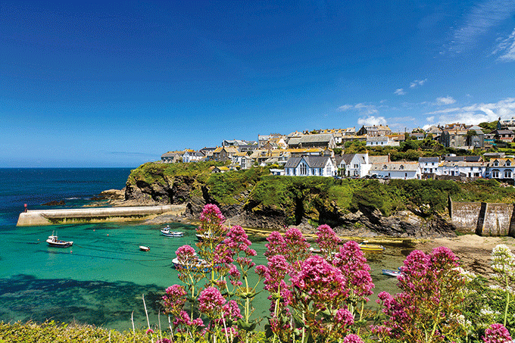

As part of the homework plan, could you please choose one task to complete and hand in to your class teacher each Monday. You can choose a different one to do each week over the next term. Please tick off the activity you have completed. We can’t wait to see what you decide to do!

Obviously this is a bit difficult at the moment but I’d love to see anything you’ve been doing/making at home, please email [calberts@dariteprimary.co.uk](mailto:calberts@dariteprimary.co.uk) if you would like to show me your work!