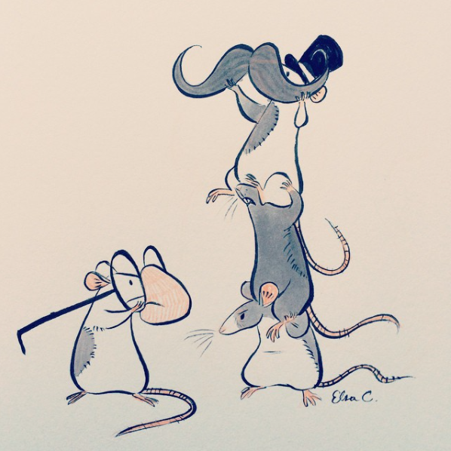
- What are the mice doing?
- Why are they trying disguises?
- Where did they get these things from?
- What are they planning?
- Do you think the disguises will work?
- Tell their story.

