Class 3

Home-Learning
Writing Booklet
Over the next few pages there are opportunities for you to write stories, diaries, and newspaper articles using picture prompts like we do in class.
When writing, set yourself the challenge of trying to do the following:
- Use as many different sentence types as you can (on the next page, there is list of a few that you’ve learnt already),
- Use interesting and challenging vocabulary,
- Use interesting and challenging punctuation,
- If writing by hand, try to use neat handwriting that is a consistent size and height,
- Use different types of clauses in your work (main, subordinate and relative),
- Use fronted adverbials to show when or how the events unfolded.
And don’t forget to use paragraphs!!

You can complete the written work in any order.

I look forward to reading your work.

All the images are from a wonderful website called Once Upon a Picture and there are hundreds more to look at if you are feeling inspired. The web address is: Onceuponapicture.co.uk
Sentence  Type | Sentence Rule and Example
2Ad | Rule: a 2Ad sentence has two adjectives before the first noun and two more adjectives after the second noun.
Example:
Mr Twit was a dirty, horrible man with dried, spaghetti in his beard.
2 Pair | Rule: the sentence begins with two related adjectives. Each pair in followed by a comma and separated with ‘and’
Example:
Exhausted and worried, cold and hungry, they were not sure how much further they could climb.
3_ed | Rule: a 3_ed sentence starts with three adjectives which end with _ed and describe emotions. Each adjective is followed by a comma.
Example:
Tired, angered, frustrated, Hermione yelled at Ron.
Verb, person | Rule: A Verb, person sentence starts with a verb, followed by a comma and then a name or personal pronoun (he, she, they, it) and then the rest of the sentence.
Example:
Tiptoeing, Harry tried to sneak past Filch and Snape without being noticed.
Noun, who/ which / where | Rule: use commas to embed the clause in a sentence. Add the information that link to the subject using who, which or where.  These are also RELATIVE CLAUSES
Example:
The deserted beach, where the shipwreck was found, was only accessible by sea.
Emotion word, comma | Rule: emotion word first, followed by a comma and then the action that relates to the emotion.
Example:
Terrified, he instantly froze to the spot.
De:de | Rule: Description: detail is a compound sentence with two independent clauses separated by a colon. The first clause is descriptive and the second one adds more detail.
Example:
Hogwarts was special: it had become Harry’s home.
Some; others | Rule: Some; others sentences are compound sentences which begin with some and have a semi-colon to replace the word ‘but’
Example:
Some people love football; others can’t stand it.
Double ly | Rule: the sentence must end with two adverbs which add detail to the sentence and describe the action of the verb.
Example:
They laughed loudly and shrilly.
All the W’s | Rule: the short sentence must start with a W word (what, who, where, when, why, will, would, what if) and end with a question mark.
Example:
Would there be another opportunity like this one? Why did this happen? When would it end?
There are many others that you have been taught, can you remember and use any of them?
Over the coming weeks, I will add some more to the Class 3 Page on the Darite School Website
Story
Planning prompts:
Who is in the picture?
What has happened to them?
Where are they going?
Where are they leaving?
Why?

Planning Boxes
Introduction

Introduce the main characters.
Introduce the story setting.
Build-Up

Develop the characters and the setting.
The points that lead up to the conflict or climax (high point) in the story.
Conflict/Climax

The conflict or climax in the story.
How do the characters react?
Resolution
How the conflict is resolved and the ending to the story?
Story
Planning prompts:
Who is in the picture?
What has happened to them?
Where are they going?
Where are they leaving?
Why?

Planning Boxes

Introduction

Introduce the main characters.
Introduce the story setting.
Build-Up

Develop the characters and the setting.
The points that lead up to the conflict or climax (high point) in the story.
Conflict/Climax

The conflict or climax in the story.
How do the characters react?
Resolution
How the conflict is resolved and the ending to the story?

Story
Planning prompts:
Who is in the picture?
What has happened to them?
Where are they going?
Where are they leaving?
Why?
Planning Boxes
Introduction

Introduce the main characters.
Introduce the story setting.
Build-Up

Develop the characters and the setting.
The points that lead up to the conflict or climax (high point) in the story.
Conflict/Climax

The conflict or climax in the story.
How do the characters react?
Resolution
How the conflict is resolved and the ending to the story?
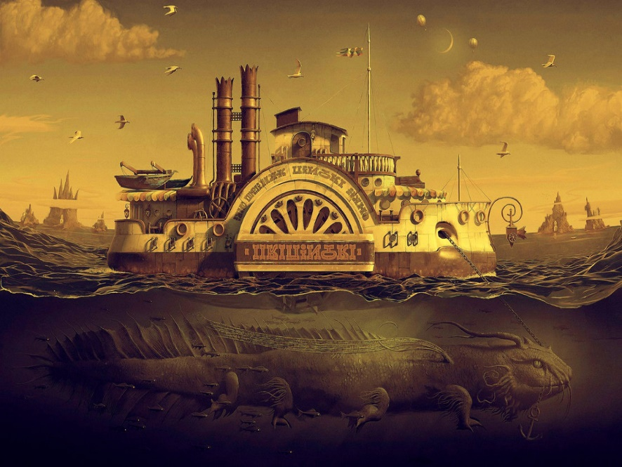
Story
Planning prompts:
Who or what is in the picture?
What has happened to them?
Where are they going?
Where are they leaving?
Why?
Planning Boxes
Introduction

Introduce the main characters.
Introduce the story setting.
Build-Up

Develop the characters and the setting.
The points that lead up to the conflict or climax (high point) in the story.
Conflict/Climax

The conflict or climax in the story.
How do the characters react?
Resolution
How the conflict is resolved and the ending to the story?

Diary
Planning prompts:
Who is in the picture?
What has happened to them?
What are they doing?
Why are they writing in a diary/logbook?
Is he alone?

Remember to write in the first person (I, we, etc.) and in the past tense.

Planning Boxes
Introduce the main character or characters.
Introduce the story setting of the diary.
Develop the characters and the setting.
What has led the “author” to write in their diary?
Remember to include the “character’s” thoughts and feelings.
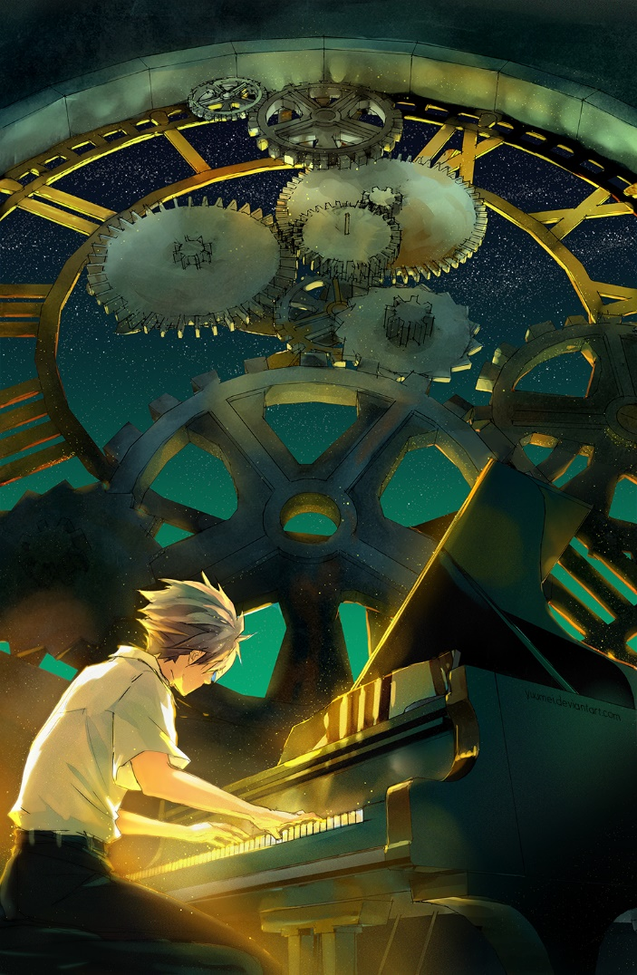
Diary
Planning prompts:
Who is in the picture?
What has happened to them?
What are they doing?
Why are they writing in a diary/logbook?
What is making the cogs turn? Are they important?

Remember to write in the first person (I, we, etc.) and in the past tense.

Planning Boxes
Introduce the main character or characters.
Introduce the story setting of the diary.
Develop the characters and the setting.
What has led the “author” to write in their diary?
Remember to include the “character’s” thoughts and feelings.

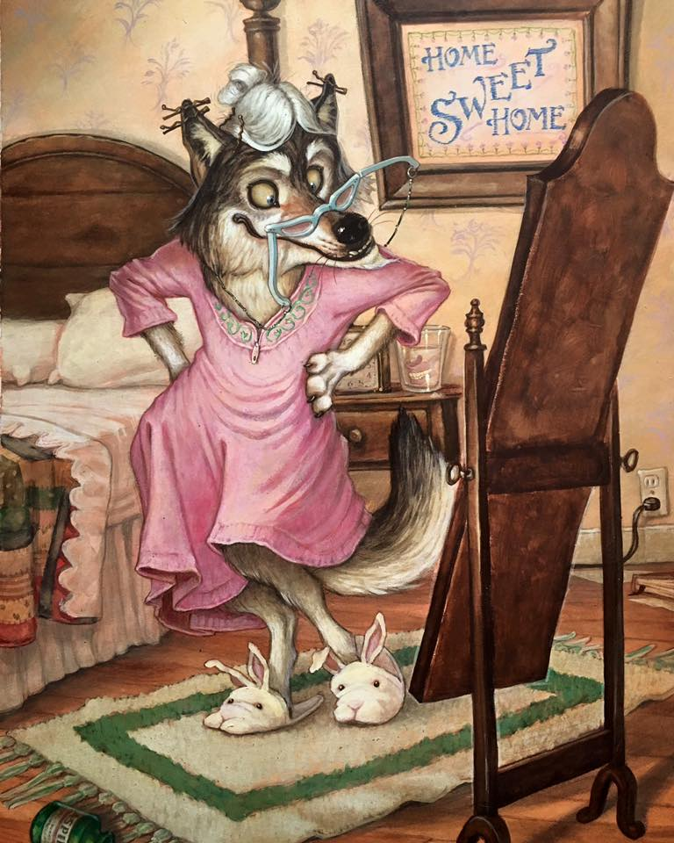
Diary
Planning prompts:
Who is in the picture?
What has happened to them?
What are they doing?
Why are they writing in a diary/logbook?
Do you recognise them from a fairy tale?
What does his body language tell you about his thoughts and feelings?

Remember to write in the first person (I, we, etc.) and in the past tense.
Planning Boxes
Introduce the main character or characters.
Introduce the story setting of the diary.
Develop the characters and the setting.
What has led the “author” to write in their diary?
Remember to include the “character’s” thoughts and feelings.
Diary
Planning prompts:
Who is in the picture?
What has happened to them?
What are they doing?
Why are they writing in a diary/logbook?
What are they carrying in those jars? Why?
What does his body language tell you about his thoughts and feelings?
Remember to write in the first person (I, we, etc.) and in the past tense.
Planning Boxes
Introduce the main character or characters.
Introduce the story setting of the diary.
Develop the characters and the setting.
What has led the “author” to write in their diary?
Remember to include the “character’s” thoughts and feelings.

Newspaper
Planning prompts:
What is in the picture?
What has happened?
Who else is involved?
Who has been affected?
What will happen next?
Remember to write in the third person (he, she, they) and in the past tense.
Planning Boxes
Headline
Subtitle
Introductory paragraph
What are the main events being reported?
Conclusion
What pictures and captions will you include?
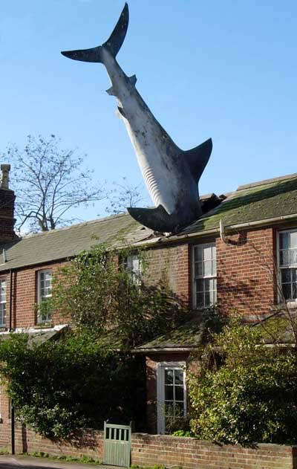
Newspaper
Planning prompts:
What is in the picture?
What has happened?
Who else is involved?
Who has been affected?
What will happen next?
Remember to write in the third person (he, she, they) and in the past tense.
Planning Boxes
Headline
Subtitle
Introductory paragraph
What are the main events being reported?
Conclusion
What pictures and captions will you include?

Newspaper
Planning prompts:
What is in the picture?
What has happened?
Who else is involved?
Who has been affected?
What will happen next?
Remember to write in the third person (he, she, they) and in the past tense.
Planning Boxes
Headline
Subtitle
Introductory paragraph
What are the main events being reported?
Conclusion
What pictures and captions will you include?
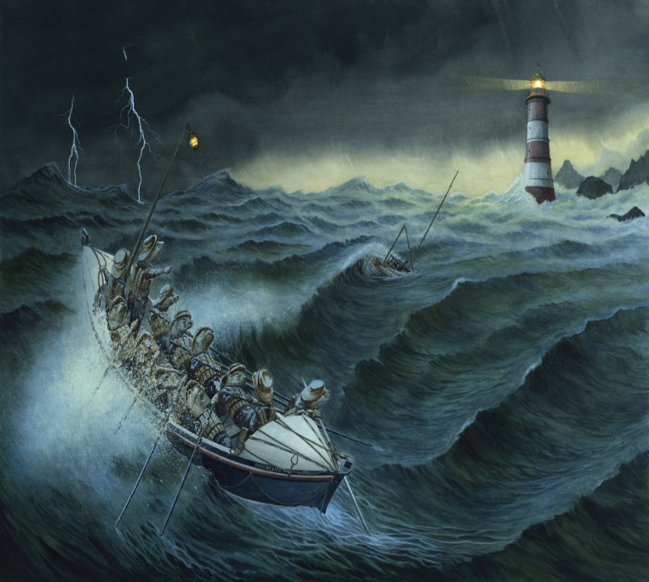
Newspaper
Planning prompts:
Who is in the picture?
What has happened?
Who has been affected?
What will happen next?
Will they be saved? Who saved them? How?
Remember to write in the third person (he, she, they) and in past tense. Planning Boxes
Headline
Subtitle
Introductory paragraph
What are the main events being reported?
Conclusion
What pictures and captions will you include?

