Class 3

Home-Learning

Reading Booklet

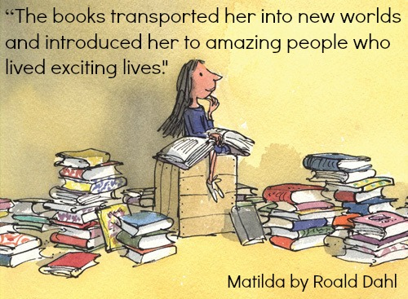

Although I have included some set text reading work in this pack, there is also an opportunity for you to develop your reading skills with your own chosen books.
The following activities will work for both fiction and non-fiction books but some of the questions may be more suited to one more than the other.
I have included some question stems on the next page, but you can also create your own if you wish.

Instructions:
- Choose a book or audiobook that interests you.
- After every 2-3 pages, choose 1-3 VIPERS questions from the question stems and answer them. Try to choose different questions each time and record your answers.
- When you feel ready, create your own questions using the question stems to help you. Try to choose from a range of VIPERS reading skills and record either the questions you’ve create or your answers – or both if you wish!
- This can be repeated with any book you choose.
Challenge: repeat this with a range of genres or both fiction and non-fiction books.
- After you’ve read a book, complete the book review that’s on the following pages.

Reading skill | Definition and question stems for each reading skill.
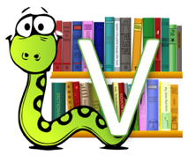  Vocabulary | Find and explain the meaning of words in context  What do the words ...... and …… suggest about the character, setting and mood?  Which word tells you that….?  Which keyword tells you about the character/setting/mood?  Find one word in the text which means……  Find and highlight the word that is closest in meaning to…….  Find a word or phrase which shows/suggests that…….
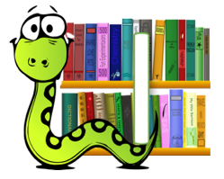  Infer | Make and justify inferences using evidence from the text.  Find and copy a group of words which show that…  How do these words make the reader feel? How does this paragraph suggest this?  How do the descriptions of …… show that they are ……..  How can you tell that……  What impression of …… do you get from these paragraphs?  What voice might these characters use?  What was …. thinking when…..
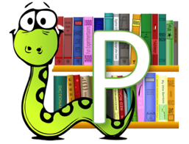  Predict | Predict what might happen from the details given and implied  From the cover what do you think this text is going to be about?  What is happening now? What happened before this? What will happen after?  What does this paragraph suggest will happen next? What makes you think this?  Do you think the choice of setting will influence how the plot develops?  Do you think… will happen? Yes, no or maybe? Explain your answer using evidence from the text.
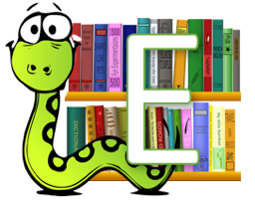  Explain | Explain how content is related and contributes to the meaning as a whole.  - Explain how meaning is enhanced through choice of language.  - Explain the themes and patterns that develop across the text.  - Explain how information contributes to the overall experience.  Why is the text arranged in this way? What is the author’s point of view?  Is the use of ….. effective? What affect does ….. have on the audience?  The mood of the character changes throughout the text. Find and copy the phrases which show this.  How does the author engage the reader here?  Which words and phrases did ….. effectively?  Which section was the most interesting/exciting part?
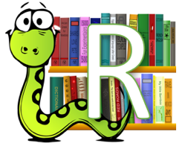retrieve | Retrieve and record information and identify key details from fiction and non-fiction.  How would you describe this story/text? What genre is it? How do you know?  How did…? How often…?  Who had…? Who is…? Who did….?  What happened to…?  What does…. do?  What can you learn from …… from this section?  Give one example of……
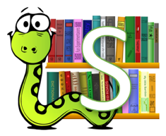Summarise or Sequence | Summarise the main ideas from more than one paragraph  Can you number these events 1-5 in the order that they happened?  What happened after …….?  What was the first thing that happened in the story?  Can you summarise in a sentence the opening/middle/end of the story?  In what order do these chapter headings come in the story?  Can you sequence the main events of the plot?
Fiction Book Review
Title:_____________________________________________________________________
Author: _______________________________________________________________
Key points of the plot:

Setting (this can be description or a picture):

Main character or characters (this can be a description, picture or a picture labelled with information from the text):

Why I gave this book these stars:_____________________________________________________________________________________________________________________________________________________________________________________________________________________________________________________________
Fiction Book Review
Title:_____________________________________________________________________
Author: _______________________________________________________________
Key points of the plot:

Setting (this can be description or a picture):

Main character or characters (this can be a description, picture or a picture labelled with information from the text):

Why I gave this book these stars:_____________________________________________________________________________________________________________________________________________________________________________________________________________________________________________________________
Fiction Book Review
Title:_____________________________________________________________________
Author: _______________________________________________________________
Key points of the plot:

Setting (this can be description or a picture):

Main character or characters (this can be a description, picture or a picture labelled with information from the text):

Why I gave this book these stars:_____________________________________________________________________________________________________________________________________________________________________________________________________________________________________________________________
Non-Fiction Book Review
Title:_____________________________________________________________________
Author: _______________________________________________________________
Summary of the book:

Favourite fact that I discovered:

Three things I discovered by reading this book:

Three new words I have learnt and what they mean:
1.
2.
3.
Why I gave this book these stars:_____________________________________________________________________________________________________________________________________________________________________________________________________________________________________________________________
Non-Fiction Book Review
Title:_____________________________________________________________________
Author: _______________________________________________________________
Summary of the book:

Favourite fact that I discovered:

Three things I discovered by reading this book:

Three new words I have learnt and what they mean:
1.
2.
3.
Why I gave this book these stars:_____________________________________________________________________________________________________________________________________________________________________________________________________________________________________________________________

Non-Fiction Book Review
Title:_____________________________________________________________________
Author: _______________________________________________________________
Summary of the book:

Favourite fact that I discovered:

Three things I discovered by reading this book:

Three new words I have learnt and what they mean:
1.
2.
3.
Why I gave this book these stars:_____________________________________________________________________________________________________________________________________________________________________________________________________________________________________________________________

