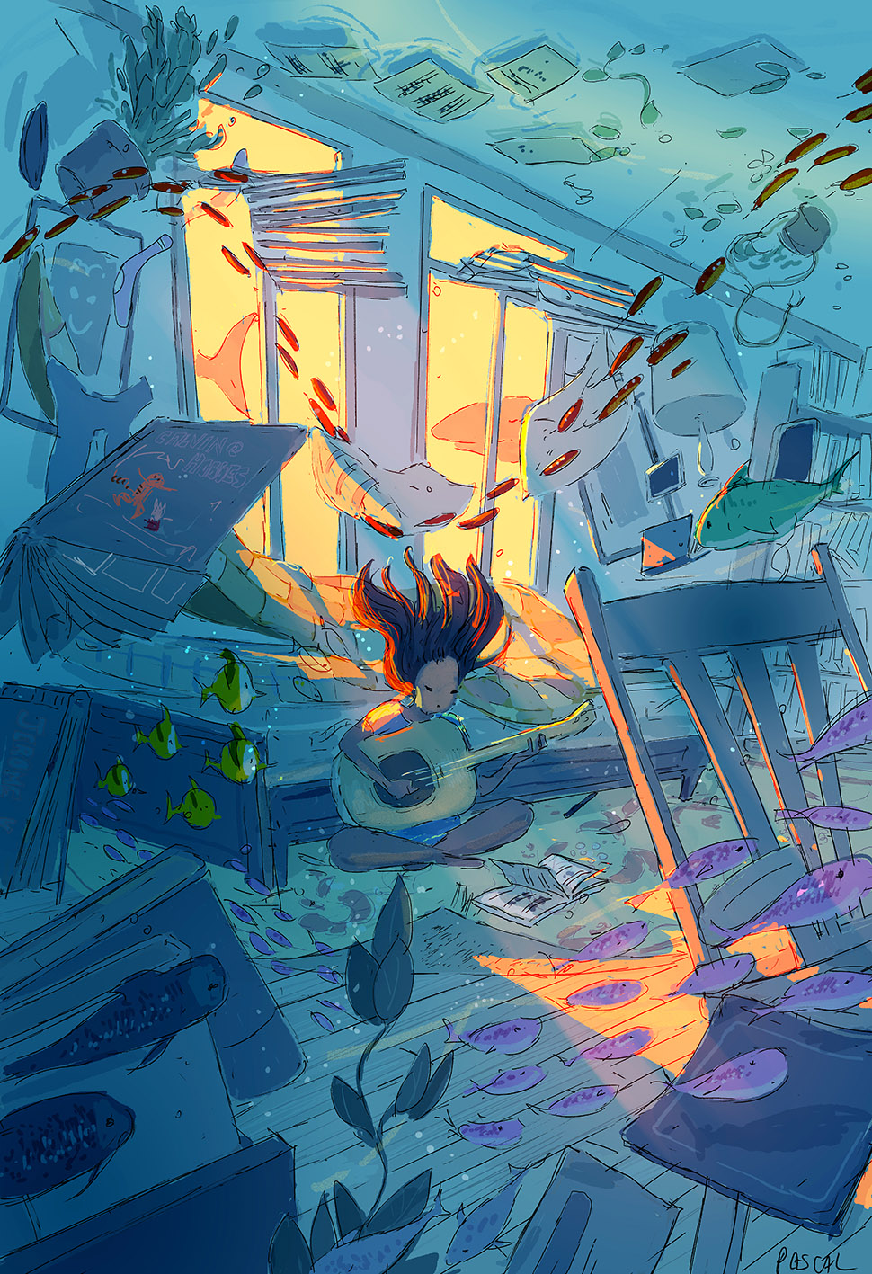

- What is happening here?
- What is the person doing? What song do you think they are playing?
- Where did all of the underwater creatures come from? What made them appear?
- What is going to happen next? Will the room ever return to normal?
- Why is the picture called ‘Way Past’?

