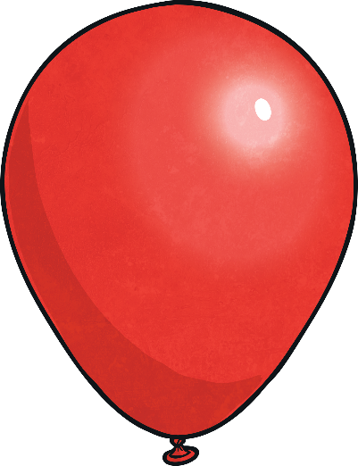
,
Commas
I put on my coat, hat and scarf.
,
Apostrophe
We’re going to the park today.
!
Exclamation Mark
What big teeth you have!
Please leave a space!
- What time is it
- It was dark outside
- he weather did not spoil the day.
- “Stop right there ” the guard shouted.
- I live with Mum Dad and Steve.
- Jake s bag fell on the floor.
- What a short temper he has
- Hassan and his sister waited for
the bus

Finger Space
What is your favourite part of the day?
?
Question Mark
I go to school and every day.
.
Full Stop
ABC
Capital
Letters
Mrs Romilda was born on Christmas Day in Nairobi, Kenya.
Add the correct punctuation to these sentences. Use the balloons below to help you.
Popping Punctuation: Missing Punctuation
We’re going to the park today.
,
Apostrophe
Please leave a space!
!
Exclamation Mark
What big teeth you have!
Finger Space
Insert all of the missing punctuation into these sentences.
Use the balloons below to help you.

What is your favourite part of the day?
Mrs Romilda was born on Christmas Day in Nairobi, Kenya.
ABC
Capital
Letters

.
Full Stop
?
Question
Mark
I go to school and every day.
I put on my coat, hat and scarf.
,
Commas
- What time is it
- It was dark outside
- the weather did not spoil the day.
- “Stop right there” the guard shouted.
- I live with Mum Dad and Steve.
- Jakes bag fell on the floor.
- What a short temper he has
- Hassan and his sister waited for
the bus

Popping Punctuation: Missing Punctuation

Popping Punctuation: Missing Punctuation
Insert all of the missing punctuation into these sentences.

- what time is it
- it was dark outside
- the weather did not spoil the day
- stop right there the guard shouted
- i live with mum dad and steve
- jakes bag fell on the floor.
- what a short temper he has
- hassan and his sister waited for the bus

Write your own sentences which include each of the following pieces
of punctuation:

!
Exclamation Mark
What big teeth you have!

,
Commas
I put on my coat, hat and scarf.

,
Apostrophe
We’re going to the park today.
Popping Punctuation: Missing Punctuation Answers

- What time is it?  - It was dark outside.  - The weather did not spoil the day.  - “Stop right there!” the guard shouted.  - I live with Mum, Dad and Steve.  - Jake’s bag fell on the floor.  - What a short temper he has!  - Hassan and his sister waited for the bus. | - What time is it?  - It was dark outside.  - The weather did not spoil the day.  - “Stop right there!” the guard shouted.  - I live with Mum, Dad and Steve.  - Jake’s bag fell on the floor.  - What a short temper he has!  - Hassan and his sister waited for the bus. | - What time is it?  - It was dark outside.  - The weather did not spoil the day.  - “Stop right there!” the guard shouted.  - I live with Mum, Dad and Steve.  - Jake’s bag fell on the floor.  - What a short temper he has!  - Hassan and his sister waited for the bus.  Accept any sentences which accurately contain the correct type of punctuation, such as:  - How wonderful the weather is today!  - I love to eat apples, bananas and oranges.  - Simon’s pencil case has robots on it.

