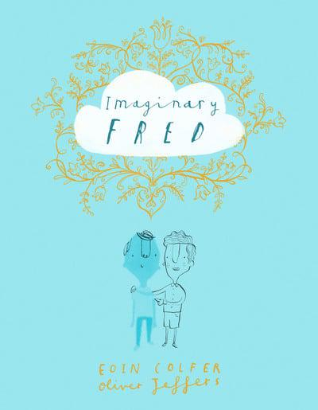
Meet Imaginary Fred

I expect that lots of you will have been watching Oliver Jeffers reading his books live. There is one book which really seems right for the strange times we are in, when we can’t easily go out and see our friends: Imaginary Fred. Watch Oliver reading the book here: https://www.oliverjeffers.com/books#/abookaday/
Introduce your own imaginary friend! This is a lovely book all about friends and friendship. Why not create (or bring to life) an imaginary friend. You may already have one or maybe you used to have one when you were smaller. Maybe you have never had one, but now is a perfect time to create one!
Here are some questions to get you thinking:
• Is your imaginary friend a person, an animal, an object?
• What is their name?
• What makes them such a good friend for you?
- What makes them special?
• What do they look like?
• Are they helpful, naughty, kind, cheeky, or funny?
Bring them to life!
• You could draw them (maybe try using dots like in Oliver Jeffers’ illustrations). • You could make them from Lego/Duplo or plasticine /playdough. • You could cut out pictures of real people from magazines and put them together to make your imaginary friend. I wonder what adventures you and your friend might have? You could try drawing some of the adventures or telling and writing the stories.

