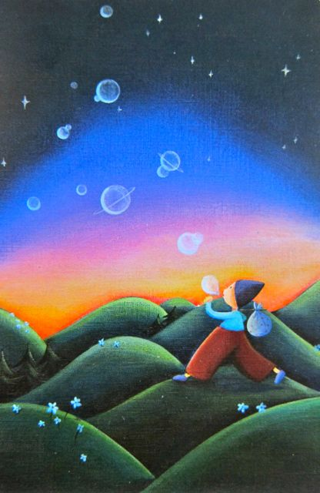
- What is this person doing?
- How old are they?
- What are they carrying in their sack?
- Where did he/she come from? Where is he/she going?
- Did they just discover how to make bubble planets or have they been doing this for a long time?
- What happens to the bubble planets after they are formed?
- Are they real planets? Is there life on any of them?
- If you could create a planet, what would you make it from? What would the environment on your planet be like? Would there be any life? What kinds of creatures would live there? How would you keep your planet a safe place?

- Choose to write:
  - A story about the bubble planet maker
  - An explanation – How Bubble Planets Are Made
  - Instructions – How To Make A Bubble Planet
  - An informative guide to bubble planets

