Phase 4
Focus for the week: Phase 4 sounds.

 | Monday | Tuesday | Wednesday | Thursday | Friday
Revisit/ Review | Recall all letter sounds (s a t p i n m d g o c k ck e u r h b f f l ll ss j v w x y z qu sh ch th ng ai ee igh oa oo ar or ur ow oi ear air ure). | Recall all letter sounds (s a t p i n m d g o c k ck e u r h b f f l ll ss j v w x y z qu sh ch th ng ai ee igh oa oo ar or ur ow oi ear air ure). | Recall all letter sounds (s a t p i n m d g o c k ck e u r h b f f l ll ss j v w x y z qu sh ch th ng ai ee igh oa oo ar or ur ow oi ear air ure). | Recall all letter sounds (s a t p i n m d g o c k ck e u r h b f f l ll ss j v w x y z qu sh ch th ng ai ee igh oa oo ar or ur ow oi ear air ure). | Recall all letter sounds (s a t p i n m d g o c k ck e u r h b f f l ll ss j v w x y z qu sh ch th ng ai ee igh oa oo ar or ur ow oi ear air ure).
Teach | Teach reading two-syllable words  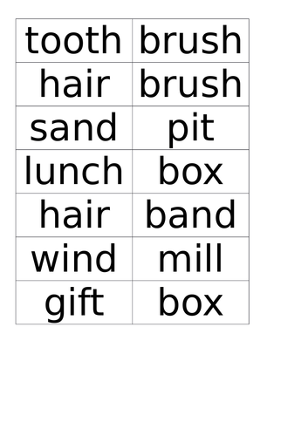 | Repeat teaching two –syllable words. If children confident try harder words. Letter, tablet, growing,children. Encourage children to clap put the syllables. | Teach spelling two-syllable words.  (See resource card). | Teach reading tricky words were, there, little, one  Teach spelling tricky words they, all, are | Teach reading tricky words were, there, little, one  Teach spelling tricky words they, all, are
Practise | Play what’s in the box with two syllable words. | Children take it in turn to think up their own poly syllabic words. Everyone clap them out. Write them up on the board. | Children use w/b’s to write and show two-syllable words given by teacher. | Play countdown using HFW’s and tricky words. | Children use w/b’s to quick write HFW’s & tricky words given by the teacher.
Apply | Children to write the sentence  Fred and Brett spent a week in Spain. | Children to read the sentence  Milk is good for children’s teeth. | Children to write the sentence  A drip from the tap drops in the sink. | Children to write the sentence  The windmill has seven sails. | Children to write the sentence  There was one little bird on the branch.
Assessment: Give the sound when shown any phrase 2/3 letter.  Be able to orally blend and segment CVC words. |  |  | Be able to read tricky words- the, to, I, no, go me, be, he, she, we, they, was, you, are, said and all.  Start recognising said, have, do, some, little, there, out, what, one, like, come, so, were and when.

