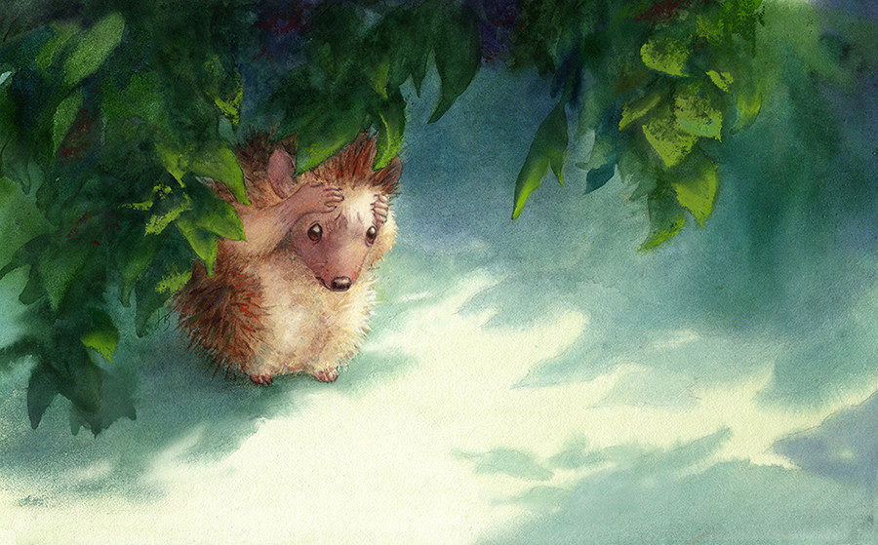

- Where is the hedgehog?
- What is it doing?
- How is it feeling? How do you know?
- Why is the hedgehog here? Why is it alone?
- The title of this illustration is, ‘Hedgehog Needs a Hug’. Why does the hedgehog need a hug?
- Tell/write this hedgehog’s story. Will it ever find someone to hug?

