Literacy

Read and respond to the Supertato books, if you have access to them or watch the videos of the stories on YouTube.
Create your own Supertato story using things from around your house to create the characters- i.e potatoes, carrots, broccoli, paper for a cape and mask, pens to draw your characters facial expressions.
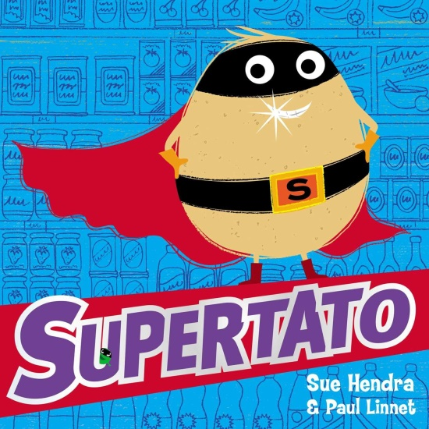
Record your story on a tablet using the characters to role play props or use paper to write what the characters are saying as speech bubbles and take photographs and then create your own Supertato comic. You could put them into pic collage.
Use nouns, verbs and adjectives to write character descriptions of your superhero and draw a picture.
Design a wanted poster for the Evil Pea!
Write a newspaper report explaining what has happened to the veggies!
Create a Superhero sketch book cover with descriptions of what you would look like and what powers etc. you would have as a superhero.

