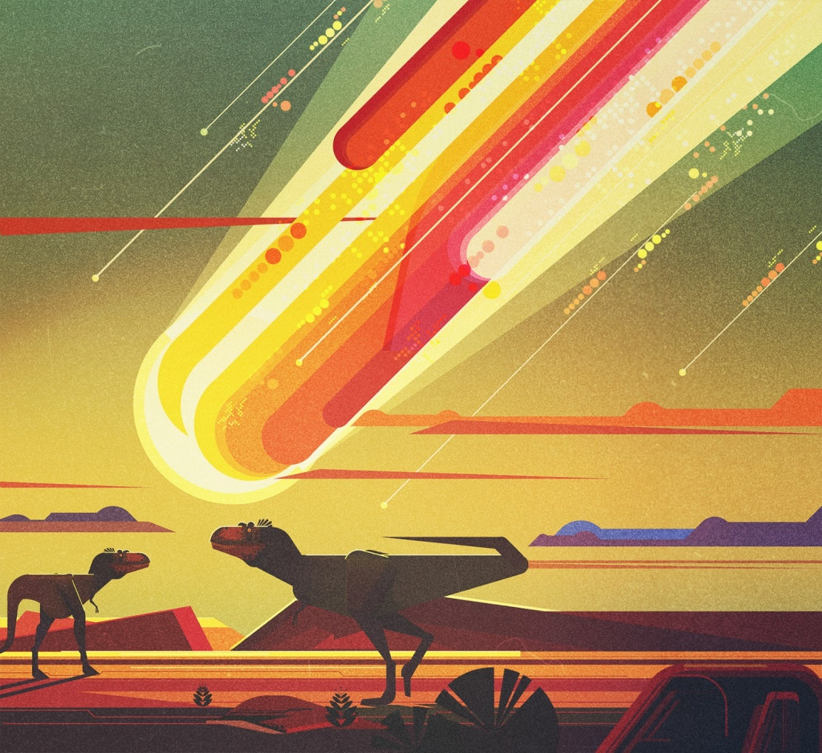
Comprehension- 8th June 2020

- What can you see in this picture?
- What do you think is happening here?
- What might the dinosaurs be thinking at this moment?
- When were dinosaurs around?
- Why did they die out?
- Research the different species of dinosaur. Which is your favourite/least favourite? Which was the largest/smallest? Can you group them by their diet? How else could you group them?

