Year R Activities: Week beginning 8th June

Maths
- Find out how many legs each of these minibeasts have and write down each number correctly:
- A bee
- A ladybird
- A spider
- A worm
- A caterpillar
- An ant
- A centipede
- Put these numbers in order from smallest to largest:
12 3 8 10
Put these numbers in order from largest to smallest:
10 1 7 20
Write down 3 numbers larger than 6.

- Take a look at some of the home learning activities that ‘White Rose Maths’ have provided for us. https://whiterosemaths.com/homelearning/early-years/
English
- Listen to the story of ‘The Very Busy Spider’ using this link: https://www.youtube.com/watch?v=TfL0g-XRxnA Can you retell the story using your voice? Draw a picture of your favourite part of the story and write a sentence to tell me about it. You might link to use the sentence starter, ‘I liked it when…’
- Listen carefully to the story of ‘The Very Busy Spider.’ Every time you hear the name of an animal, write it down! Don’t forget to robot-talk each word as you hear it to make sure you use your phonics carefully.
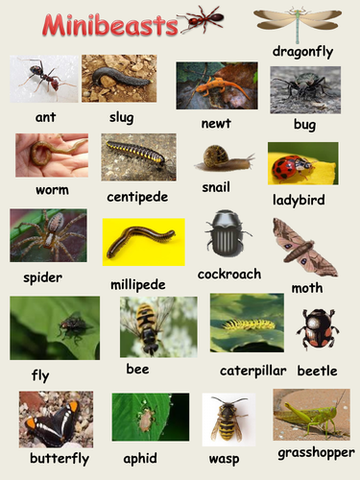
- Look at this picture:
Choose your favourite minibeast and write a fact file to tell me about it. You might include it’s name, it’s colour, the amount of legs it has, where it lives and what it enjoys eating.

Reading

- Please read as much as possible! There are extra e-books to read by following this link if you have run out at home: https://home.oxfordowl.co.uk/
Phonics

- I have added some Powerpoint resources to revisit your sounds at the beginning of phase 3.
- Visit this website: https://www.phonicsbloom.com/ and choose to play phase 3 or 4 games.
Other Learning
- Don’t forget PE with Joe Wicks every morning at 9am (you can also do them later in the day).
- Go for a walk with your family or explore your garden and complete a minibeast hunt.
- Create your own minibeast! You might use cardboard boxes or different junk modelling materials or you might use lego. Perhaps you might paint a picture of a minibeast or maybe you have a different idea. Be creative!
- Lots of minibeasts have patterns on them. Create your own pattern using objects you have at home. You might like to use the colours you have seen on your minibeast hunt, for example a bee has yellow stripes, then black stripes, then yellow stripes etc.

