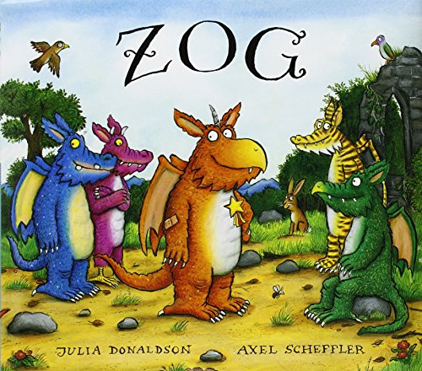
Literacy
Dragon school
Outcomes
- Your child will use their knowledge of the story to write a school report for Zog
- Your child will make the movements and sounds made by Zog as described in the story

After reading the story of Zog to your child, recap the things that Zog needed to learn each year in Madam Dragon’s School and how Zog faced challenges with each:
- in Year 1 he learned to fly and crashed into a tree
- in Year 2 he learned to roar and made his throat hoarse
- in Year 3 he learned to blow fire and his wing tip caught alight
- in Year 4 he learnt how to capture a princess
- in Year 5 he learned to fight a knight
Explain that we all face challenges when we are learning, and the most important thing is to keep trying and persevering. Ask your child to think about how Zog eventually earned his golden star – do they think he deserved it at any other point in the story?
Task
Ask your child if they remember getting a school report. Do they know what it is and why a teacher writes them? Show your child the resource below: Explain they are going to use their knowledge of the story to write a school report for Zog. Highlight that a school report should explain how he has tried hard to develop his dragon skills, what he has done particularly well and any challenging areas he can improve upon.
Extension
Become Madam Dragon and allow your child to practise their own dragon skills at your dragon school. You can give out the golden stars for your child to earn while completing the activities.
Flying – in a large area, such as a garden or park, encourage your child to fly, soar, swoop and loop the loop.
Roaring – using musical instruments such as drums or shakers, or by banging on a saucepan see who can make the biggest ‘roar’ sound?
Blowing fire – attach strips of red, orange and yellow tissue paper to sticks, which your child can blow to make moving ‘flames’ as if they are breathing fire.

