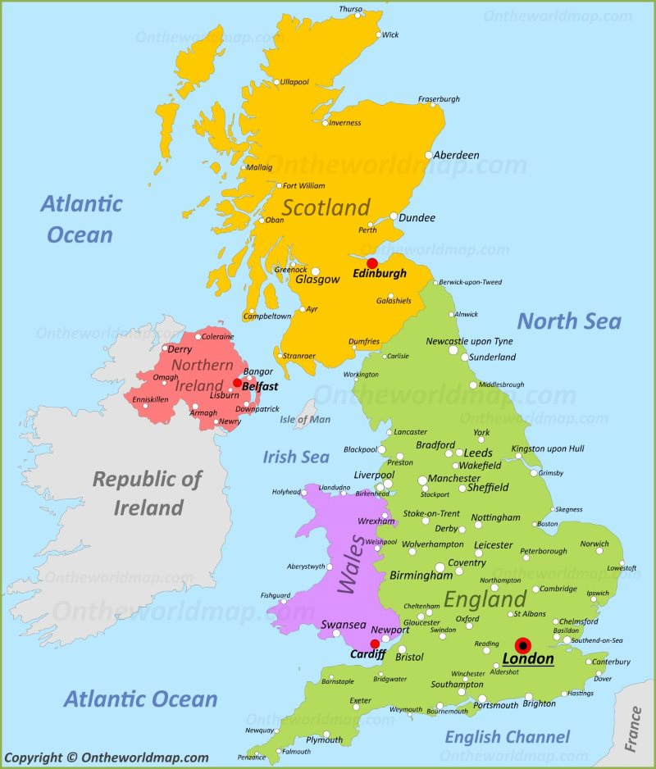
Topic Learning Journey: We are Britain!
To learn about their own family’s story and cultural traditions and to begin to realise these may be different to those of other people.
To celebrate each person’s uniqueness.
To continue research of own family’s story and to tell these stories to others.
To investigate the location of UK and other countries across the world.
Enthuse children about medieval history, knights; give simple explanation of Magna Carta.
To create shields which use appropriate symbols to capture something of their identity and family tradition.
To learn about London, the Capital City of UK.
To make models based on famous London buildings.
Geography and Art
Use aerial photographs and plan perspectives to recognise landmarks and basic human and physical features; devise a simple map.

To find out about the 4 nations which make up the UK; focus – England.
Make a large class poster/collage of information and images.
- Use an assortment of sources to research topic: ‘England’.
- Contribute written information and images to large collage poster: ‘England’.
- Learn about symbols of England: St George; flag; the rose; the 3 lion’s motif.

Participate in a St George’s Day Pageant; eat an English picnic, play cricket and dance around a Maypole. Make a lion mask; tell a fellow lion what you’ve learnt about England.
Teaching Outcomes
To find out something of the culture and traditions of the 4 nations which make up the UK; focus - England.
To contribute to the celebrations and explain a viewpoint.
Scotland
Participate in a homemade Highland Games with some Scottish dancing and a Scottish picnic. Make Nessie sock puppets who explain to one another what they have learnt about Scotland.
Wales
Learn about St David - patron saint of Wales, but what’s his name in the Welsh language?
Ireland
Hear about Finn MacCool and how there are stories about how giants formed certain features of the country including the Giant’s Causeway.
To begin to understand what a beach holiday is like.
To find capitals in each of the four countries of the UK and name the surrounding seas and popular seaside locations.
Use a range of tools and equipment to make a puppet theatre.
Examine Ramsgate sands and compare it to the seaside today.

Teaching Outcomes
To understand how Victorians spent leisure time and consider the similarities and differences of modern holidays.
To make a wooden spoon puppet.
Back on the train; discuss history of trains through the image entitled The Railway Station; talk about Isambard Kingdom Brunel´s influence; travel to seaside town of Tenby in Wales, look at life in rock pools, wildlife at the seaside and go scuba diving!
Teaching Outcomes
To examine aerial photographs and maps, then devise a simple map with symbols.

Children will:

Listen to and enjoy ‘The Blue Balloon’ by Mick Inkpen.
Imagine a ride in a hot air balloon.
Identify basic human and physical features from aerial photos.

Rivers and Canals- Wind in the willows
Castles-
To mix paint colours that represent individual’s skin tone and hair colour; to create a realistic self-portrait.
To begin research of children's own family’s story.
To learn about different families’ stories and cultural traditions.
Pre-learning Experience:
I am learning to explain what I would like to find out, and what I already know about the UK.

Where our journey ends…
Pupils will develop their knowledge about the world, the United Kingdom and their locality. They will learn about human and physical geography and begin to use geographical skills, including first-hand observation, to enhance their locational awareness.
Children’s questions-
Start the journey here…

