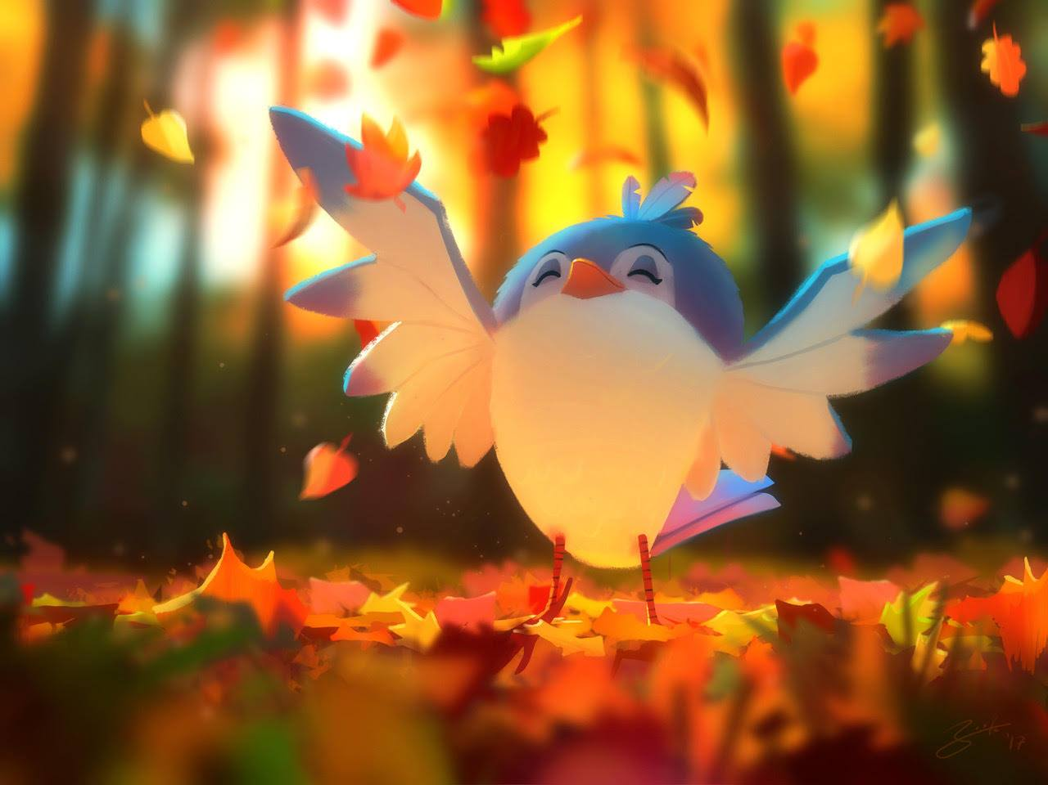
- Describe this picture.
- What is the bird doing? Why?
- Is the bird happy? How do you know? Why is it feeling this way?
- What do you like best about autumn? What about the other seasons? Imagine you could put the best parts of each season in a bottle – what would you include? What would you write on each label? [e.g. AUTUMN: carpets of crisp, burnt orange leaves crunching beneath your feet; the smell of earth and bark and bonfires; sunsets casting the world in a golden glow…]
- Which is your favourite season? Why?
- Do all countries experience seasons in the same way? Investigate and try to explain why/why not.

