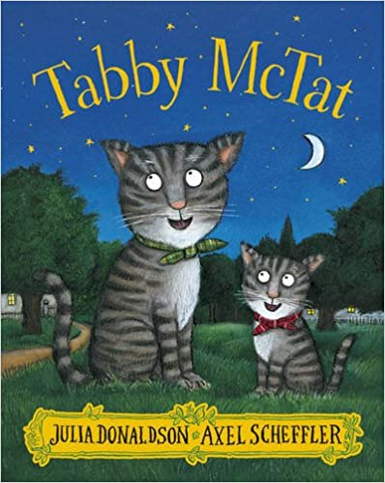
Literacy- Missing Cat
Objectives
• To compose and organise factual, descriptive writing
• To use adjectives in writing
• To create an observational drawing

Introduction
Read the first 11 pages of the story to your child, up to “But Tabby McTat wasn’t there!”
Show your child the picture of Tabby McTat when he is with the busker (pages 1-2) and ask them to describe him: white eyes, grey stripy fur, scruffy, green neck tie and white bib. Ask your child to identify how Tabby McTat differs from Sock (on pages 3-4).
Ask your child how they think Fred, the busker, feels when he can’t find his cat. How might he go about finding Tabby McTat? How about a ‘missing’ poster? What information might need to be on it (description, last seen…, please contact…)?
Explain that they are going to create a ‘missing’ poster for Tabby McTat and afterwards you will read the rest of the story.
Main task
Display a picture of Tabby McTat – you could use the picture of the front cover. Make a Missing Poster Template (see below) and encourage them to draw a detailed picture of Tabby McTat for their poster. Explain that this is like an observational drawing and needs to be as accurate as possible to help him be identified.
Your child should then describe his features and neck tie using an array of adjectives. They can also add in detail about his personality and what he might like or dislike – explain that ideas from the story, such as that he likes to ‘sing’, can also be included. Encourage your child to use their imaginations to add in detail, for example, Tabby McTat loves to be gently tickled under his chin.
Once complete, read the second half of the story to your child and perhaps challenge them to describe how Tabby McTat and Samuel Sprat differ.
Extension
Stick your child’s poster up on a wall and ask them to pretend they are Fred, the busker. Can they sing the favourite song and then make an announcement to explain what’s happened and ask for help?
You may wish to provide sentence starter prompts such as:
“I’m glad you like my busker song. I used to sing it with my cat but now…”
“Can anybody help me? I’ve lost my cat. He is…”
“That’s my favourite song but I am sad when I sing it now because…”

