Year R Activities: Week beginning 22nd June
Maths
- In the bear’s house there were lots of things that were different sizes. Play this game to find the tallest, shortest, biggest or smallest items: http://resources.hwb.wales.gov.uk/VTC/big_small/eng/Introduction/MainSession.htm
- Draw a picture of the three houses from the story ‘The Three Little Pigs’ BUT you may only use triangle and rectangle shapes! Add some colour to make your drawings beautiful. Remember, the houses were made from straw, sticks and bricks.
- Take a look at some of the home learning activities that ‘White Rose Maths’ have provided for us. There is an activity to access each day if you would like some extra Maths jobs! https://whiterosemaths.com/homelearning/early-years/
English
- Watch the animated story of ‘Goldilocks and the Three Bears’ using this link: https://www.youtube.com/watch?v=qOJ_A5tgBKM Answer these questions with your adult:
-What did Goldilocks eat in the story?
-What did Goldilocks break?
-How did Goldilocks make the bears feel being in their house?
-Why did Goldilocks run away?
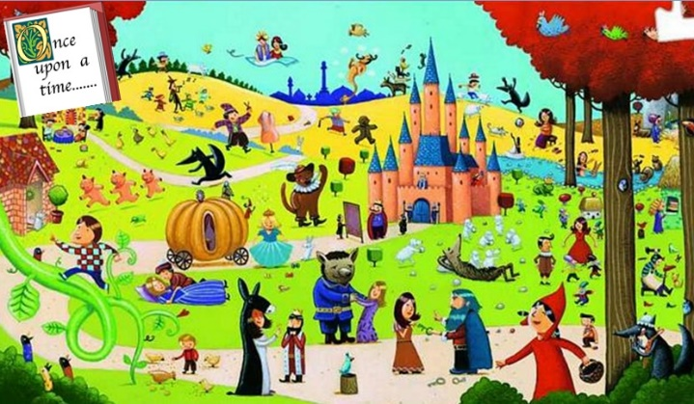
-Did the story have a happy ending? Why?
- Look at this picture:
Can you spot any characters that you know from stories that you have read before? Play I spy with your grown up to spot characters and things from the picture, ‘I spy with my little eye, something that starts with the sound…’
- Choose your favourite character from the picture. Draw your own picture of them and colour it in carefully. Write some labels to tell me what they look like or what their personality is like inside!
- Little Red Riding Hood meets The Big Bad Wolf on her way to Grandma’s house. Create a poster that helps people to stay safe and warns them about The Big Bad Wolf.

Reading

- Please read every day! There are extra e-books to read by following this link if you have run out at home: https://home.oxfordowl.co.uk/
Phonics
- Watch the daily phonics PowerPoint.
- Visit this website: https://www.ictgames.com/phonicsPop/index.html and pop the phonemes carefully!
One way to practise your neat handwriting is write out each word carefully.
Other Learning
- Don’t forget PE with Joe Wicks is 3 times a week at 9am (you can also do them later in the day).
- The ‘Three Little Pigs’ built houses out of straw, sticks and bricks in their story. Create a fourth house for the little pigs. What material(s) will your house be made from?
- Personal best challenge! Find an empty container such as a cup or a lunchbox and turn it on its side. Find a ball or if you don’t have a ball, a pair of rolled up socks and roll them into the container. You will get one point each time your ball successfully rolls into the container. You are allowed 10 rolls. How many points can you score? Try this activity again later on in the week and see if you can improve your score!

