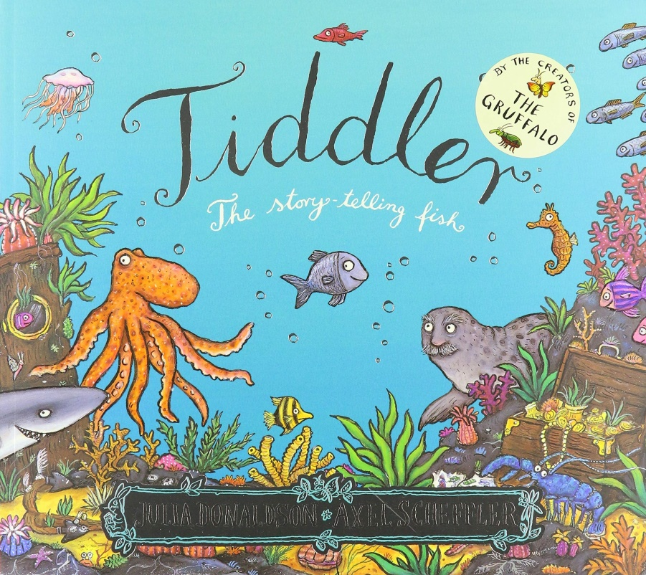
Sea Creature Fact Files
Objectives
• To find information from non-fiction texts.
• To organise information under different headings.
Outcomes
• Children will find information about a specific sea creature.
• Children will organise information under headings.

Introduction
Read the story of Tiddler to your child and ask them to recall all the different creatures or characters from the story that they can remember. Make a list of these creatures. (Tiddler can be found on YouTube).
Ask your child how they could find out more information about these types of sea creatures. Explain that you will be using the internet and non-fiction books to find information and facts about the sea creatures featured in the story. Choose a creature (e.g. octopus) and show your child how to look it up in the index of a book, or how to use the contents page to navigate to the right place. You can also show your child how to use a site such as: www.a-z-animals.com/animals/pictures/ to gather information.
Read a section of text from the book or website together and ask your child to tell you their favourite interesting fact from the information you have read.
Main task
Talk about an information fact file – does your child know what this is? Ask them to think of ideas for key headings for an information fact file (Eats, Lives, Appearance, Key Features, Interesting Facts) and set the challenge to create a fact file as an accompanying text for the story of Tiddler.
Your child can research one of the creatures in the story using age appropriate non-fiction books and/or the internet. They can then make a fact sheet like the one below.
Extension
Your child could create a 3D underwater scene using collage materials, featuring the sea creature from their fact file. Use an empty cereal box, with the lid taped closed and cut out the front panel.
Turn the box onto its side and decorate the inside of the box using paints, tissue paper and collage materials to look like an underwater sea bed with water, plants and coral (use the wonderful illustrations in the book by Axel Scheffler for ideas). Your child can cut-out their picture from their fact file or redraw their sea creature and hang it from the top of the box to look like it’s floating in the deep sea.

