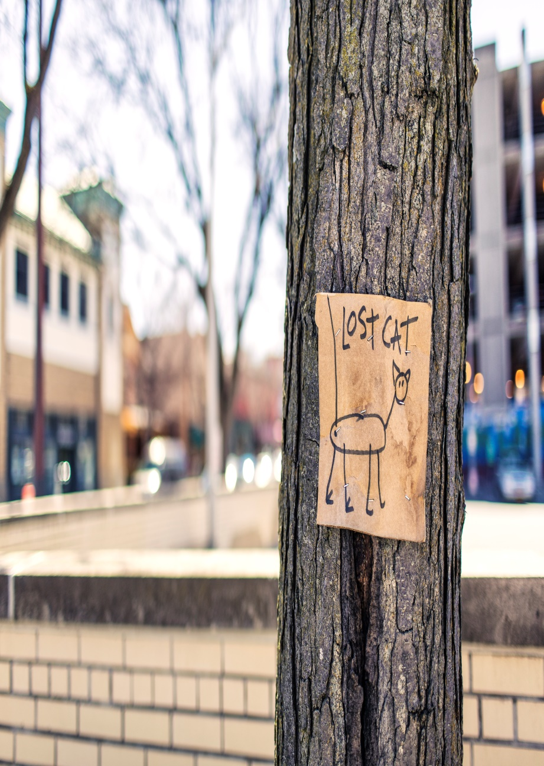
Comprehension
- Who made this poster? [Age? Gender? Nationality?]
- Why did they make it?
- Who put it up?
- When did the cat go missing?
- Do you think that this poster will help them to find their missing cat? Why/why not?
- Create an improved ‘lost cat’ poster. Grammar link: adjectives, expanded noun phrases.

