Year R Activities: Week beginning 29th June
Maths
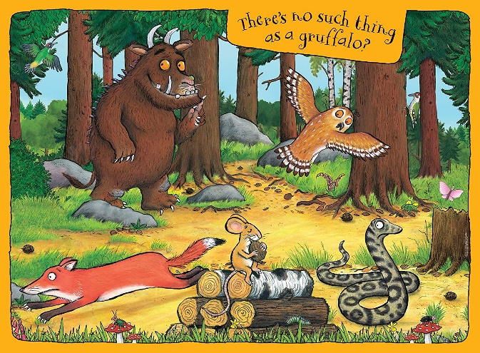
- Look at this picture from the story ‘The Gruffalo’:
What shapes can you spot? How many circles can you see? How many shapes can you spot that you don’t know the names of? Draw your own picture from the story ‘The Gruffalo’ using only circles, squares, triangles and rectangles.
- I’ve been busy solving some maths calculations but I’ve made some mistakes! Answer ‘true’ or ‘false’ to each of my calculations:
- One less than 4 is 3.
- One more than 10 is 12.
- One more than 14 is 15.
- One less than 7 is 8.
- The number 6 is larger than the number 8.
- The number 13 is smaller than the number 20.
- Take a look at some of the home learning activities that ‘White Rose Maths’ have provided for us. There is an activity to access each day if you would like some extra Maths jobs! https://whiterosemaths.com/homelearning/early-years/
English
- Watch the animated version of ‘Stick Man’ using this link: https://www.bbc.co.uk/iplayer/episode/b06t09rk/stick-man Discuss the main character in the story and answer these questions:
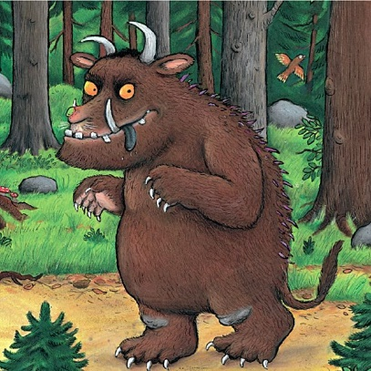
- Why does he run away from the dog?
- How many children does Stick Man have?
- Who else does Stick Man run away from?
- What was your favourite part of the story? Why?
- The witch from the story ‘Room on the Broom’ would like some help to create a magic potion! Collect some things from outside to go in your potion and create a list of the things you’ve included! If you’d like some help, I have attached some instructions onto our class page. Ask a grown-up to help you collect the things you need and stir it together!
- Look closely at this picture of ‘The Gruffalo’:
Describe The Gruffalo using adjectives (describing words) with your voice first. Can you write these adjectives down? Can you write down any of the sentences that Julia Donaldson uses in her story to describe ‘The Gruffalo?’

Reading

- Please read every day! There are extra e-books to read by following this link if you have run out at home: https://home.oxfordowl.co.uk/ I attached a reading challenge to the class page last week – how many squares can you tick off?
Phonics
- We’re going to have another week of writing sentences using the phonics we already know. Ask your grown-up to read these sentences out loud for you each day:
-Monday:
1. The boy is spoilt and bad.
2. The fire is red and hot.
3. I hear the storm.
-Tuesday:
1. The pig in a wig.
2. Ships in the port.
3. Train in the rain.
-Wednesday:
1. Cook the tea.
2. The leaf is green and wet.
3. The girl can shout loud.
-Thursday:
1. This is a good day.
2. I can see the moon up high.
3. The girl and the boy can play.
-Friday:
1. It is not dawn in the evening.
2. A cow is born in the barn.
3. Can I stay with you?
One way to practise your neat handwriting is write out each word carefully.
Other Learning
- Make your own Stick Man. Be creative! You could go for a walk with your family safely and find a fallen stick on the ground as a base for your character. You could use leaves, material or pens for the clothes.
- ‘The Gruffalo’ is one of our favourite Julia Donaldson books! Have a go at creating your own terrible creature.
- My favourite Julia Donaldson story is ‘The Smeds and The Smoos.’ The Smeds are red and The Smoos are blue. Have a go at creating your own alien creature by mixing paint to create a new colour. What will you call your creature?

