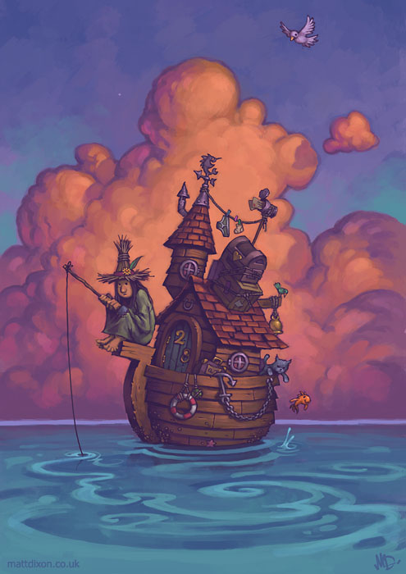

- Who is the woman?
- Why does she live on a boat?
- Does she have everything she needs?
- Is she happy?
- Is she lonely?
- Is being alone the same as being lonely?

