Year R Activities: Week beginning 6th July
Maths
- Look at my missing number patterns. Write them down and fill in the missing numbers!
- 2, 3, 4, __, 6, __, __
- 8, 9, __, __, 12, __, __
- 10, 9, 8, __, 6, __, 4, __
- 21, 22, 23, __, __, __, 27, __
- 0, 10, 20, __, 40, __, 60, 70, __
- Create your own pattern using circle and square shapes. Draw them on a piece of paper eg. circle, square, square, circle, square, square etc. and continue it. How many different patterns can you create using circle and square shapes?
- Take a look at some of the home learning activities that ‘White Rose Maths’ have provided for us. There is an activity to access each day if you would like some extra Maths jobs! https://whiterosemaths.com/homelearning/early-years/
English
- Watch the story of ‘Sally and the Limpet’ on Youtube. Write a list of all of the people that Sally helped. Use your phonics carefully to write your list.
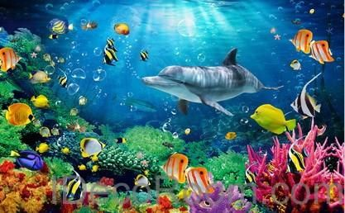
- Look at this image from under the sea. What can you see? Talk to a grown-up about what you can spot. Write a list to tell me what you can see in the picture.
- Write a sentence to talk about your favourite thing about going to the beach. You might start your sentence with ‘I like…’ or ‘My favourite thing about the beach is…’

Reading

- Please read every day! There are extra e-books to read by following this link if you have run out at home: https://home.oxfordowl.co.uk/ We have attached a reading challenge to the class pages – how many squares can you tick off?
Phonics
- Ask your grown-up to read these sentences out loud for you each day:
-Monday:
1. Twirl around in the grass.
2. The nurse helps with burns.
3. I like to eat crisps and treats.
-Tuesday:
1. The bug has six legs.
2. It is right then left.
3. I think I can stay with you.
-Wednesday:
1. The cake is big and red.
2. The queen can go in the car.
3. I am at home now.
-Thursday:
1. The zoo is far away.
2. Sing the song out loud.
3. The king is big and fat.
-Friday:
1. I might go to bed late.
2. I will not hurt the girls.
3. I will make the bed.
- Visit this website: https://www.phonicsplay.co.uk/resources/phase/2/dragons-den and choose phase 2 or 3. Read the words carefully and decide which dragon to feed the word to. Is it a real word or an alien word?
One way to practise your neat handwriting is write out each word carefully.
Other Learning
- A mosaic is a picture made up of lots of small squares. Can you create your own mosaic of a seaside scene? You could cut up pieces of coloured paper, newspapers or magazines to create your mosaic!
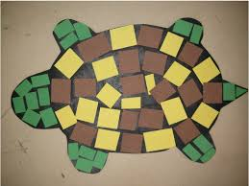
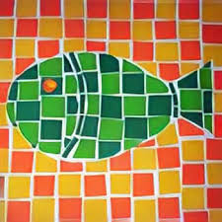

- Listen to the song ‘Under the Sea’ from ‘The Little Mermaid’ using this link: https://www.youtube.com/watch?v=GC_mV1IpjWA Have a go at singing along or creating a dance routine to the song.
- Imagine you have found a shell and that shell grants you one wish. Draw a picture of what your wish would be.

