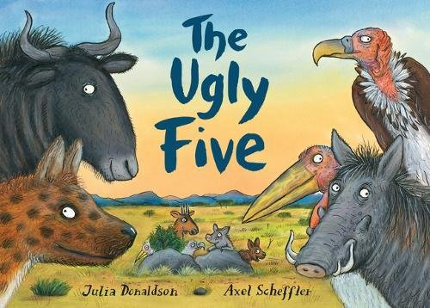
Literacy
Where in the world?
Objectives
• To recognise some of the continents in the world
• To recognise how animals live in places that are suited to them
• To understand how animals obtain food from plants and animals, using the idea of a simple food chain
Introduction
Introduce the book to your child by sharing the front cover. Ask, where do you think this story might take place? Can you recognise any of the animals shown? Without sharing the text, show the picture from the first page. Ask your child if they can work out where they think the story might take place.
Explain that it is set in Africa. Show a map of the world, pointing out where Africa is. Can your child name any other continents and point to where these are on the map, for example Europe or North America?
Read the story to your child, stopping to discuss any vocabulary that might be unfamiliar to them. Examples could include: ambled, ungainly, specimen, vile and grizzly. After reading the book, turn back to each of the Ugly Five. Discuss why these animals are suited to living in the African plains – what is this habitat like and what food sources are available? Discuss the clues in the book about what the animals eat, for example: ‘At mealtimes my habitats are really quite vile; I much prefer food that’s been dead for a while’ Ask your child to think about where the vulture gets food that has been dead for a while. You can go on to talk about why the Ugly Five wouldn’t be suited to living in other habitats around the world, for example, why wildebeest wouldn’t be suited to living in the desert and why would the warthog not like to live at the North Pole?
Main task
Give your child the pictures below: Animals around the world, work out where in the world these animals live.
Extension
Your child can draw pictures of what each of the Ugly Five animals eat and make a food chain. You might want to discuss some ideas first, or encourage your child to conduct some research using books and the internet first.
• Lappet-face vultures scavenge on carcasses of mammals such as gazelles and hares, but they also eat eggs, insects (such as locust) , and hunt live prey such as small birds (eg. flamingoes)
. • Spotted hyenas scavenge the loeftovers of bigger predators, but will also hunt mammals such as wildebeest or antelope. They also kill and eat birds, lizards, snakes, and insects.
• Wildebeest are herbivorous animals and graze on grasses, leaves and shoots.
• Marabou storks are scavengers; they eat anything from termites, flamingos and small birds to leftover scraps of mammal carcasses (with vultures and hyenas).
• Warthogs mainly eat grass, fruit, berries, roots and insects but they are also known to occasionally eat small mammals, birds and reptiles.

