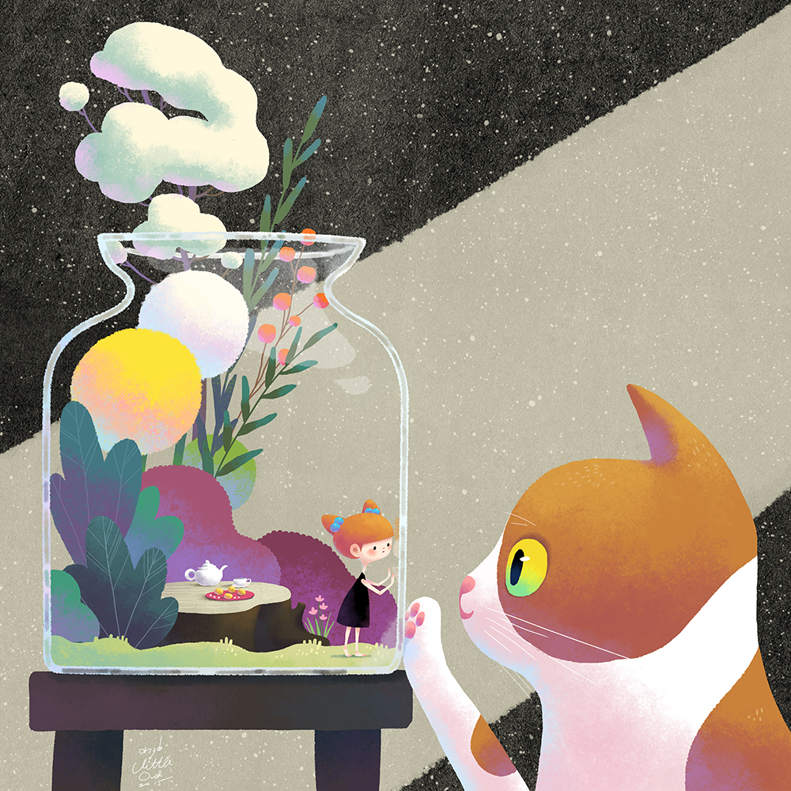
- Why is the girl inside the jar?
- How did she get there?
- Can she get out? Does she want to?
- Does she have everything she needs inside the jar?
- Why is the cat looking at her? Are they communicating? Are they friends?
- Write in first person. Choose whether you want to write from the girl’s perspective, or the cat’s.
- Imagine a world where animals keep humans as pets. Would anything be similar to our world as it is? What would be different?

