Year R Activities: Week beginning 13th July
Maths
- Create your own beach picture! You can only use rectangles, squares and circles in your picture. Think carefully about what each of these shapes look like as you draw them. Add some colour to your picture!
- Using pictures (dots) or objects, solve these addition calculations. Write each one down and solve it carefully by counting the two groups you’ve drawn or arranged:
- 2 + 5 =
- 1 + 3 =
- = 7 + 2
- = 2 + 2
- 5 + 1 =
- Take a look at some of the home learning activities that ‘White Rose Maths’ have provided for us. There is an activity to access each day if you would like some extra Maths jobs! https://whiterosemaths.com/homelearning/early-years/
English
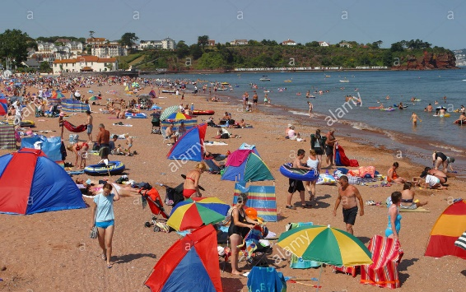
- Listen carefully to the story of ‘The Lighthouse Keeper’s Lunch using this link: https://www.youtube.com/watch?v=46wCRq50Wwg&t=23s Why do we have lighthouses? If you can, visit Smeaton’s Tower on Plymouth Hoe with your grown-up. How many stripes does it have? If you can’t visit the lighthouse, look at a picture on the internet.
- Look at this picture of a busy beach! Write a sentence to describe the sea using this sentence starter, ‘The sea is…’ Write a sentence about the sand using this sentence starter, ‘The sand looks…’ Write a sentence about something you can see in the picture using this sentence starter, ‘I can see…’
- Draw a picture of a beautiful sunny day at the beach. Write a sentence to tell me about what the weather is like in your picture.

Reading

- Please read every day! There are extra e-books to read by following this link if you have run out at home: https://home.oxfordowl.co.uk/
Phonics
- Ask your grown-up to read these sentences out loud for you each day and then write them down.
-Monday:
1. I can see the cars zoom.
2. Shout and twirl at the zoo.
3. The snail is in the rain.
-Tuesday:
1. Can I drink the tea?
2. Shut the door!
3. The queen has lots of toys.
-Wednesday:
1. The snow is cold.
2. The goat eats cake.
3. I will look at the train.
-Thursday:
1. Play outside with the boys.
2. She is not spoilt.
3. This is my green leaf.
-Friday:
1. Fish and chips for dinner.
2. Yawn in the morning.
3. I can hop, skip and jump.
Visit this website: https://www.phonicsbloom.com/uk/game/alien-escape?phase=3 and enjoy the phonics game!
One way to practise your neat handwriting is write out each word carefully.
Other Learning
- When you are playing outside have a look at your shadow. Is it as big as you or smaller? Does it move when you move or does it stay still? We can create shadow drawings. Put a piece of paper outside on the ground and place some of your toys on the paper, look at the shadows and draw around the outside of them. Dinosaurs work really well!
- When people visit the beach they like to build sandcastles and put a flag on top. Design a flag to put on your sandcastle.

