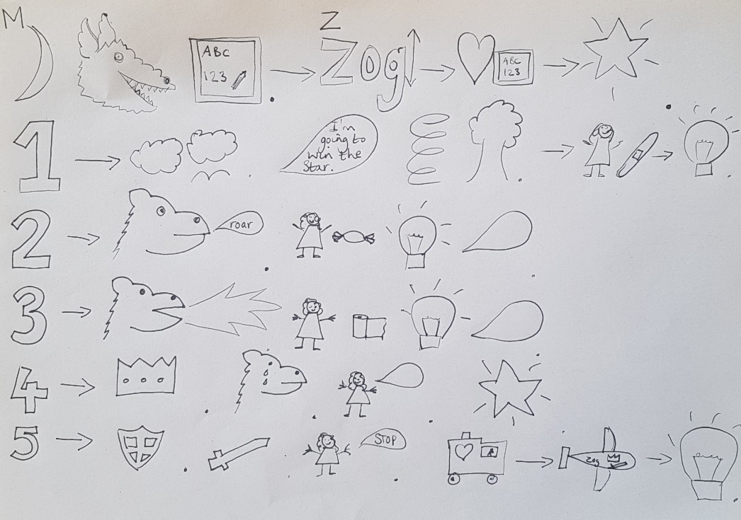

First the colourful dragons learned how to fly.

___________________ Zog flew into a tree and hurt his nose. (Sadly Unfortunately Suddenly)

___________________ Princess Pearl came along and gave Zog a plaster.

