Wednesday 13th January
LO: I am learning to persevere when I find something difficult.

How do you think the tortoise felt at the beginning of the race?

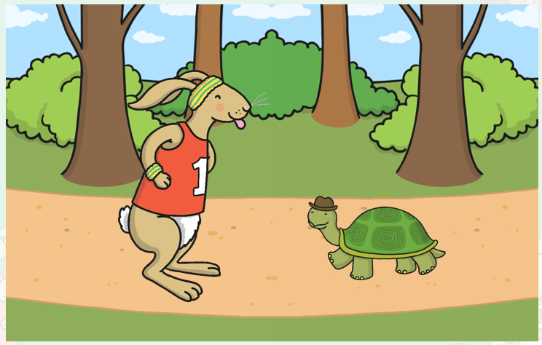

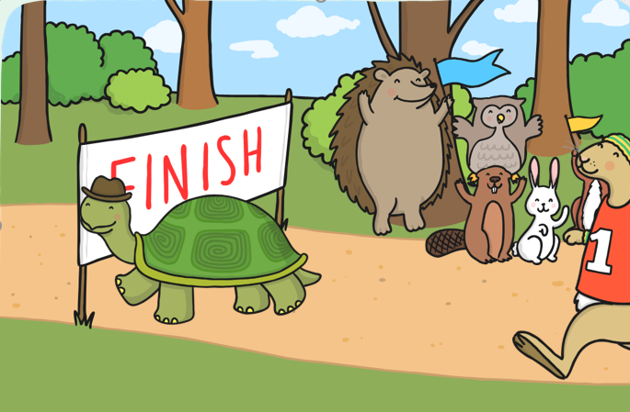
How do you think he felt at the end of the race?

