Thursday 14th January 2021
LO: I am learning to use speech.
I can write speech in a speech bubble.
I can write speech in a sentence .
I can use inverted commas to mark speech.
I can use question marks and exclamation marks in speech..
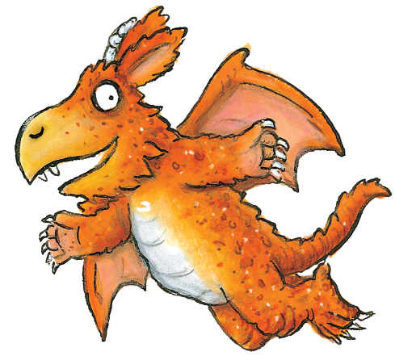
What a good idea!

“What a good idea!” said Zog.

Everything in the speech bubble goes inside the inverted commas
“ What a good idea!”
What might Zog be saying here? Write it in the speech bubble and then write it in between the inverted commas.
“____________________!” said Zog.

Now have a go on your own. Draw a picture form the story and draw a speech bubble. Write the speech inside the bubble and then have a go at writing a sentence including inverted commas. Don’t forget an exclamation mark ! or a question mark ? if you need one.

