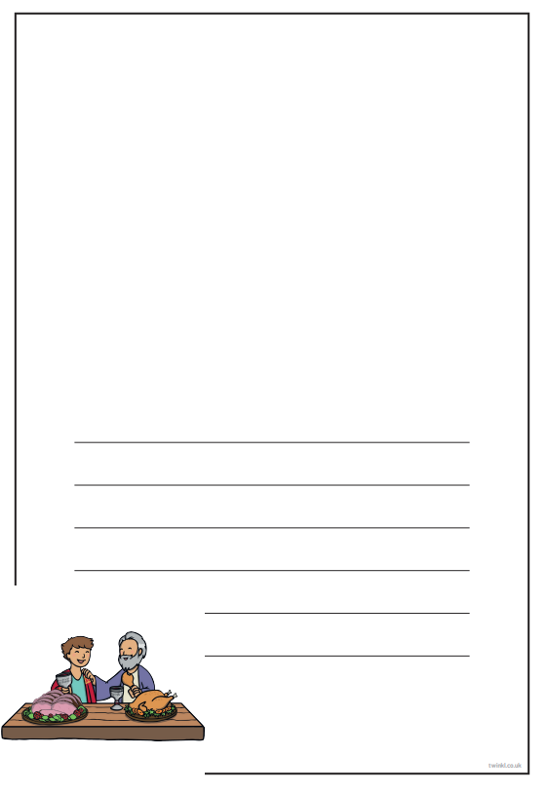

Thursday 14th January 2020

LO: I am learning to understand what Christians think about God.

Draw a picture from The Lost Son and write a sentence explaining what it means.