Monday 18th January 2021
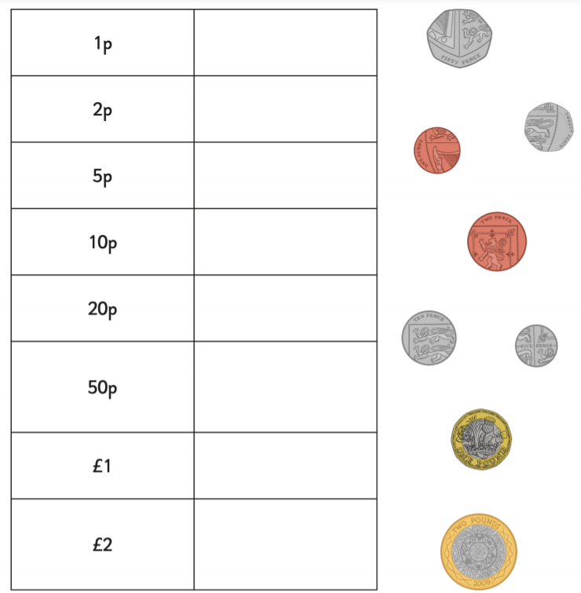
LO: I am learning to identify coins.
I can recognise 1p and 2p coins.
I can recognise 5p and 10p coins.
I can recognise 20p and 50p coins.
I can recognise £1 and £2 coins.

Flashback Four

- 5 + 2 = 10 - ____

- Draw the shape that has 3 vertices and 3 sides?

- Which day comes after Wednesday?

- 3 x 2 = ____

