Monday 18th January 2021
LO: I am learning to identify coins and notes.
I can identify all UK coins.
I can identify all UK notes.
I can compare the value of UK coins.
I can compare the value of UK notes.
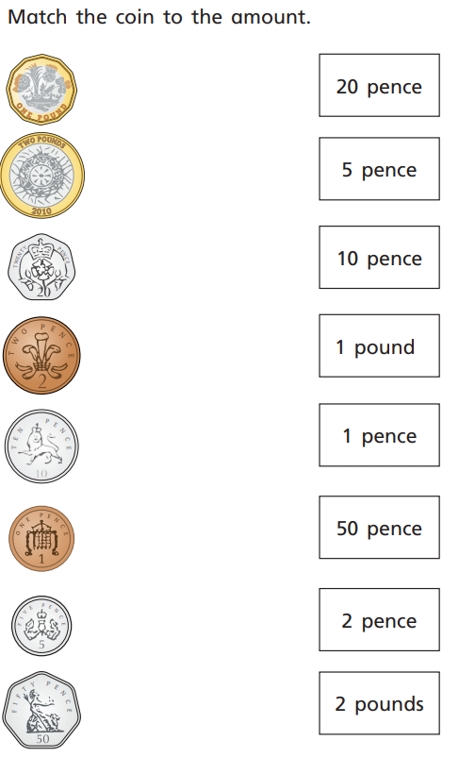

Flashback Four
- I am a 2D shape with 5 vertices and 5 sides. What shape am I?

- 27 + 33 =

- 50 - ____ = 20

- 38 > 83 True or false?

