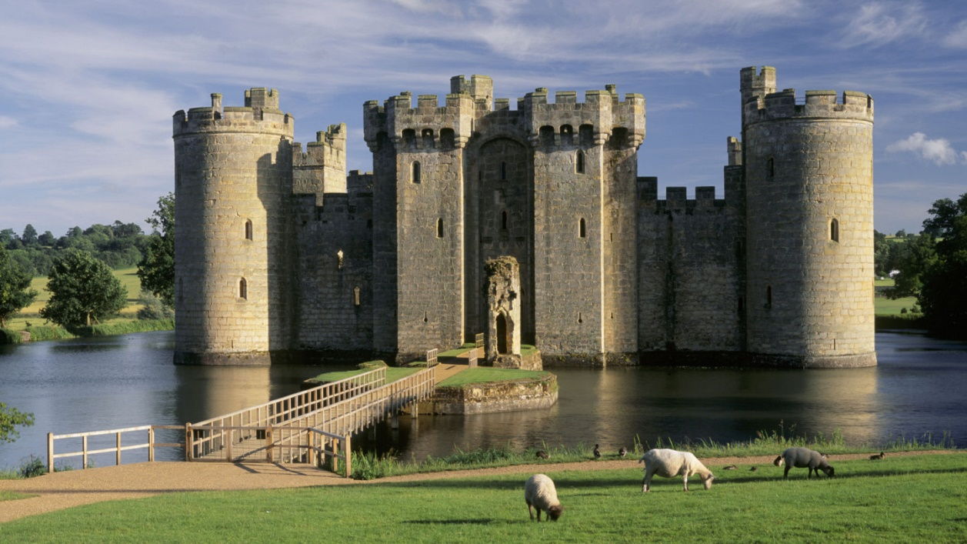

The castle is ______.

________________________