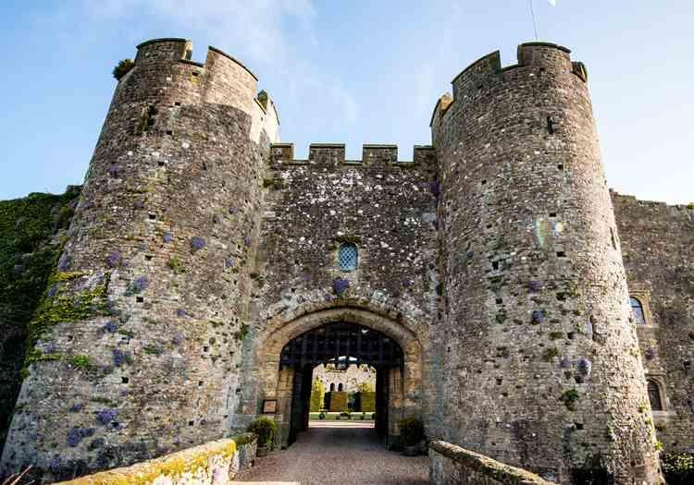
Tuesday 19th January 2021
LO: I am learning to use sounds to write words.

The castle walls are __________________.
__________________________________

