Wednesday 20th January 2021
LO: I am learning to use sounds to write words.
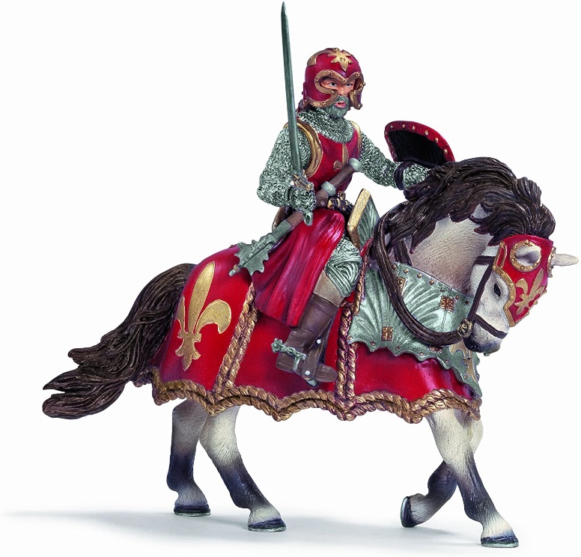

The knight has a ___ helmet.
______________________

