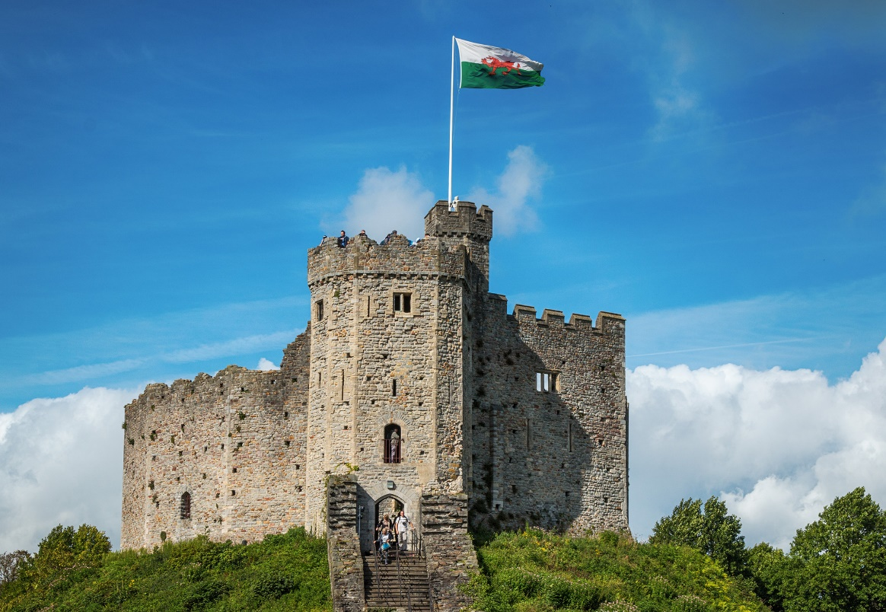
Thursday 21st January 2021
LO: I am learning to use sounds to write words.

The castle has a Welsh ____.
___________________________

