Friday 22nd January 2021
LO: I can use sounds to write words.
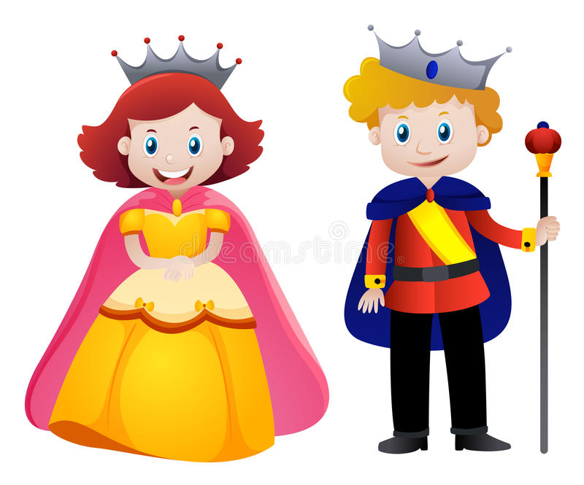
The king and queen are wearing ______.
_________________________________

