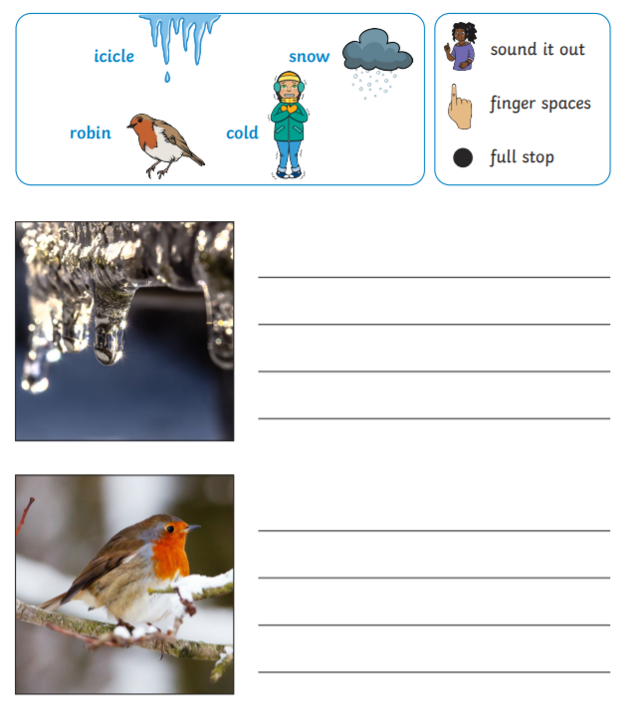
Monday 25th January 2021
LO: I am learning to use sounds to write words and sentences.
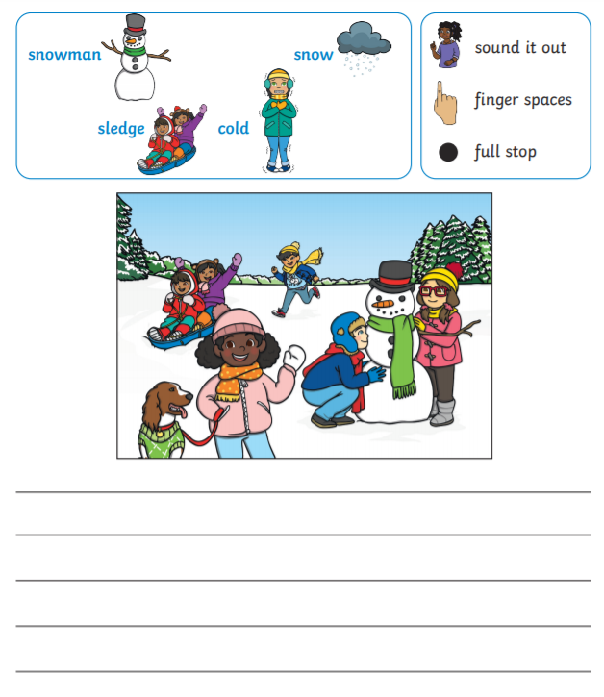
Tuesday 26th January 2021
LO: I am learning to use sounds to write words and sentences.
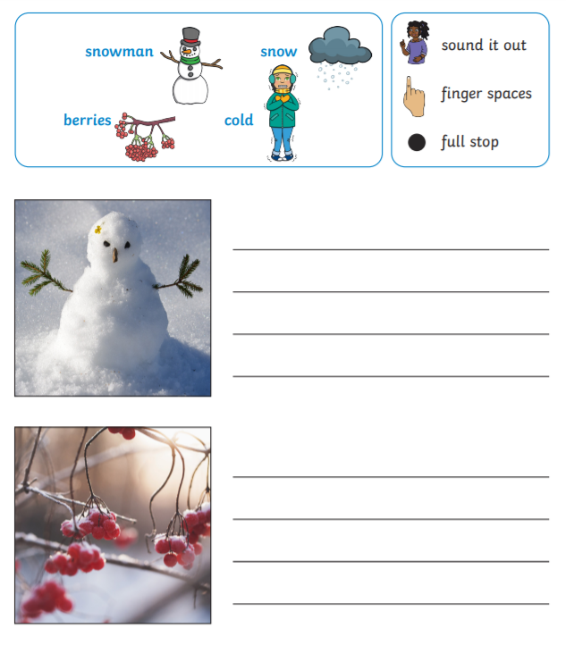
Wednesday 27th January 2021
LO: I am learning to use sounds to write words and sentences.

Thursday 28th January 2021
LO: I am learning to use sounds to write words and sentences. 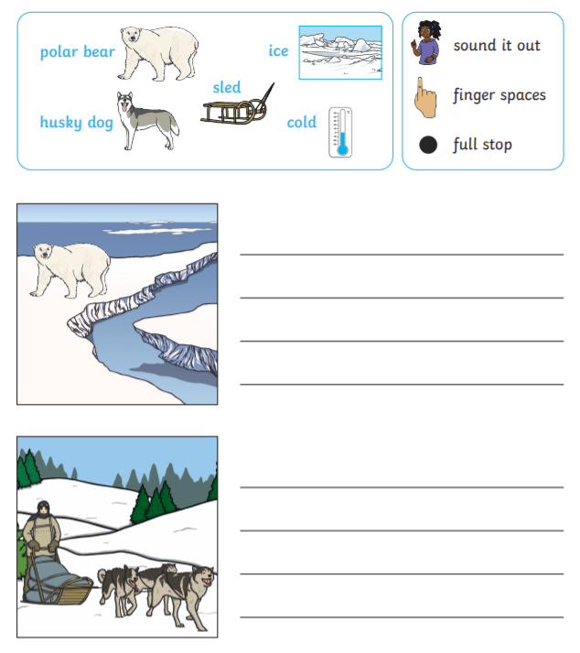
Friday 29th January 2021
LO: I am learning to use sounds to write words and sentences.
