Monday 25th January
LO: I am learning to make a given amount.
I can use one coin to pay for something.
I can use two coins to pay for something.
I can use a range of coins to pay for something.
I can find different ways of making the same amount.

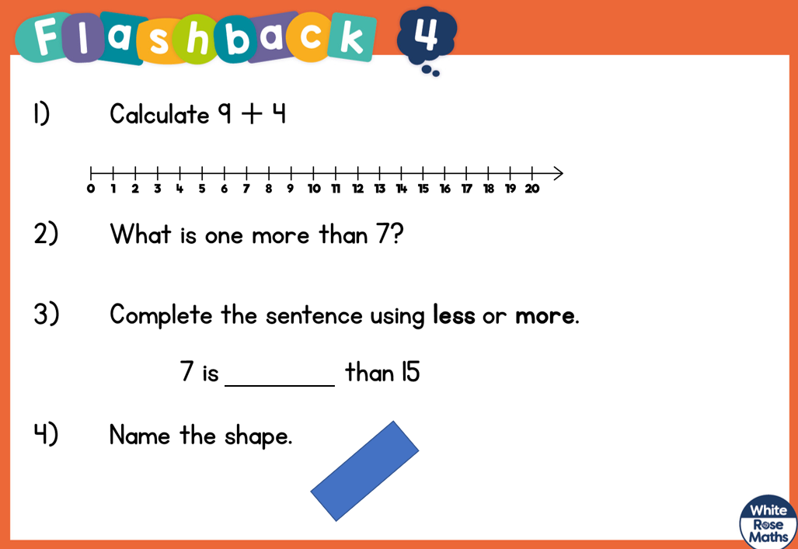

Toy | Draw the coins you would use to pay for this toy
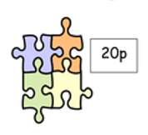
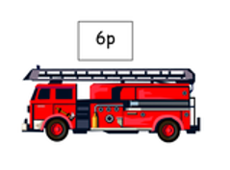
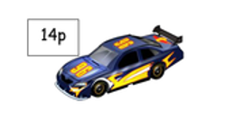
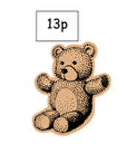
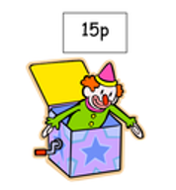
Can you find three different ways to make 15p?

