Tuesday 26th January 2021

LO: I am learning to interpret music.

Listen to this piece of music (Dance of the Knights) by Prokofiev whilst looking at this painting <https://www.youtube.com/watch?v=yH64s09G00c>

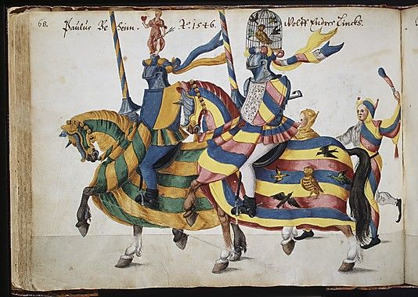German unknown artist circa. 1546

Which instruments can you hear? What do the drums make you think of?

Draw your own picture that the music makes you think of.