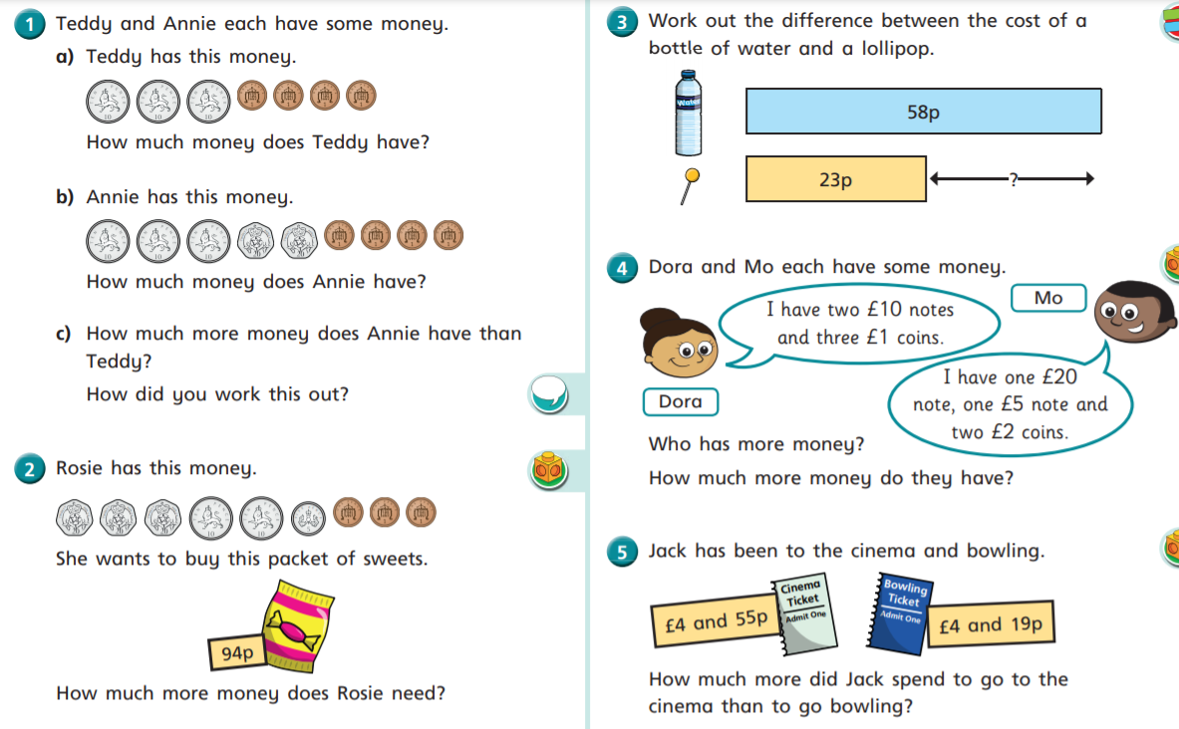

Wednesday 27th January
LO: I am learning to find the difference with money.
I can add coins and compare amounts.
I can say how much more money is needed.
I can find the difference using the bar model.
I can solve problems finding the difference.
