Wednesday 27th January
LO: I am learning to compare amounts.
I can compare coins.
I can compare amounts.
I can add coins and compare the total.
I can solve problems with comparing amounts.
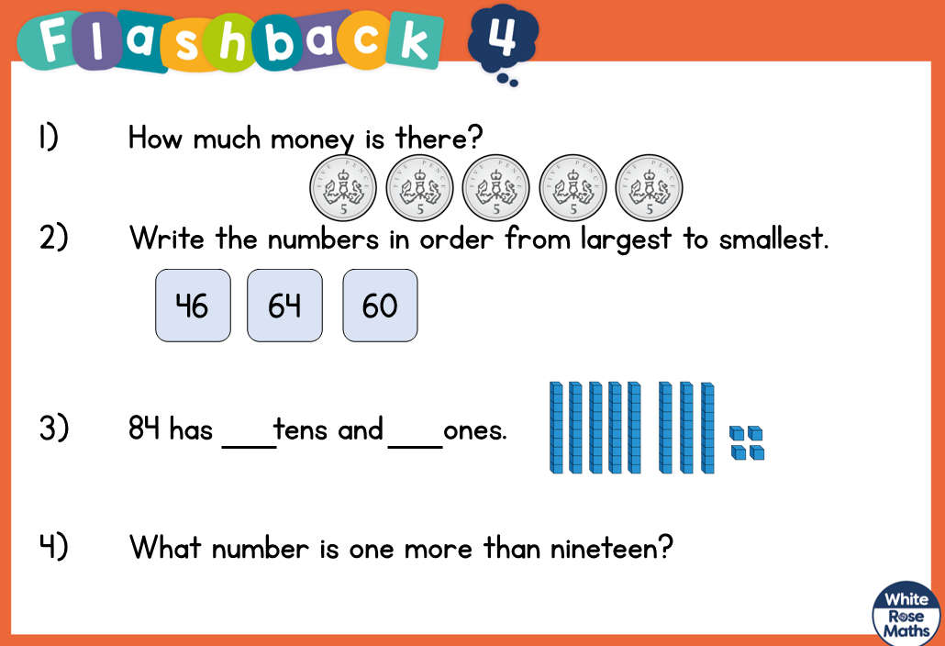
Use < > or = to show which amounts are bigger.
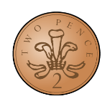
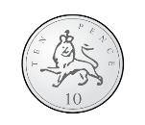

17p |  | 7p
32p |  | 23p

Sam saved money in his piggy bank to buy a comic for 15p.
Does he have enough money?
Draw the coins he needs.

