Everything you need to know about a Cloud Goblin (Nubes Cobalus)
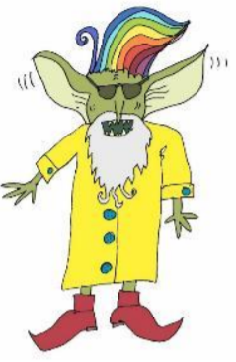
Introduction
Cloud Goblins (Nubes Cobalus) are gentle creatures who have an excellent sense of humour. Read on to find out more.

Appearance (what they look like)
Have you ever seen a Cloud Goblin? Like most goblins, they have huge feet, stubby legs and a large nose. The majority of Cloud Goblins have white, black or rainbow coloured hair. However, some have hair the colour of bright lightning. Additionally, most Cloud Goblins have big bushy beards (often with raindrops hanging from them) and huge ears, which can detect a small sound over 20 miles away. Cloud Goblins like to wear yellow raincoats and dark sunglasses.

Habitat (where they live)
Cloud Goblins live in the skies all over the world. Cloud Goblins like to live in large rain clouds (nimbostratus clouds) where they are camouflaged. Many Cloud Goblins can be found dwelling in the clouds above mountain ranges such as the Andes or the Alps.

Diet (what they eat)
Cloud Goblins eat marshmallows, candyfloss and lightning-bolt biscuits. They also love to drink frost or fog milkshakes but they must never drink rainwater because they are allergic to it.

Surprising Features
Cloud Goblins have many surprising features. Despite their short legs, they are remarkably good at jumping, which means they are often found jumping long distances from one cloud to another. Interestingly, Cloud Goblins are quite heavy and they enjoy playing snow-flake frisbee.

Hobbies
Cloud Goblins love to make shapes out of clouds. Have you ever looked at a cloud and thought: ‘That looks like a dog, a flower or a face?’ If you have, then it is probably a Cloud Goblin that has created that. Finally, the most amazing thing about Cloud Goblins is that they never sleep and they really enjoy reading Star Goblins enchanting stories

