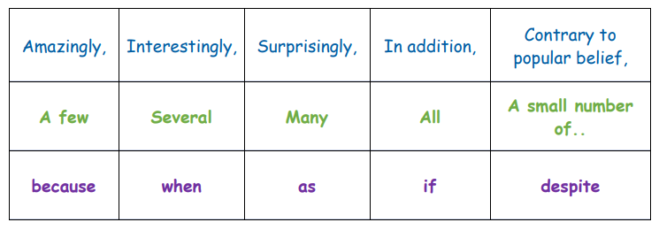
First, have a go at adding some of your own vocabulary to the table below. Try to include a mixture of all 3 types.

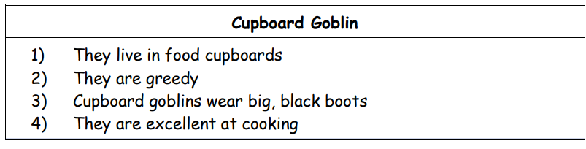
Now have a go at writing a paragraph about the Cupboard Goblin, use the facts below and some of the vocabulary from the table.
____________________________________________________________________________________________________________________________________________________________________________________________________________________________________________

