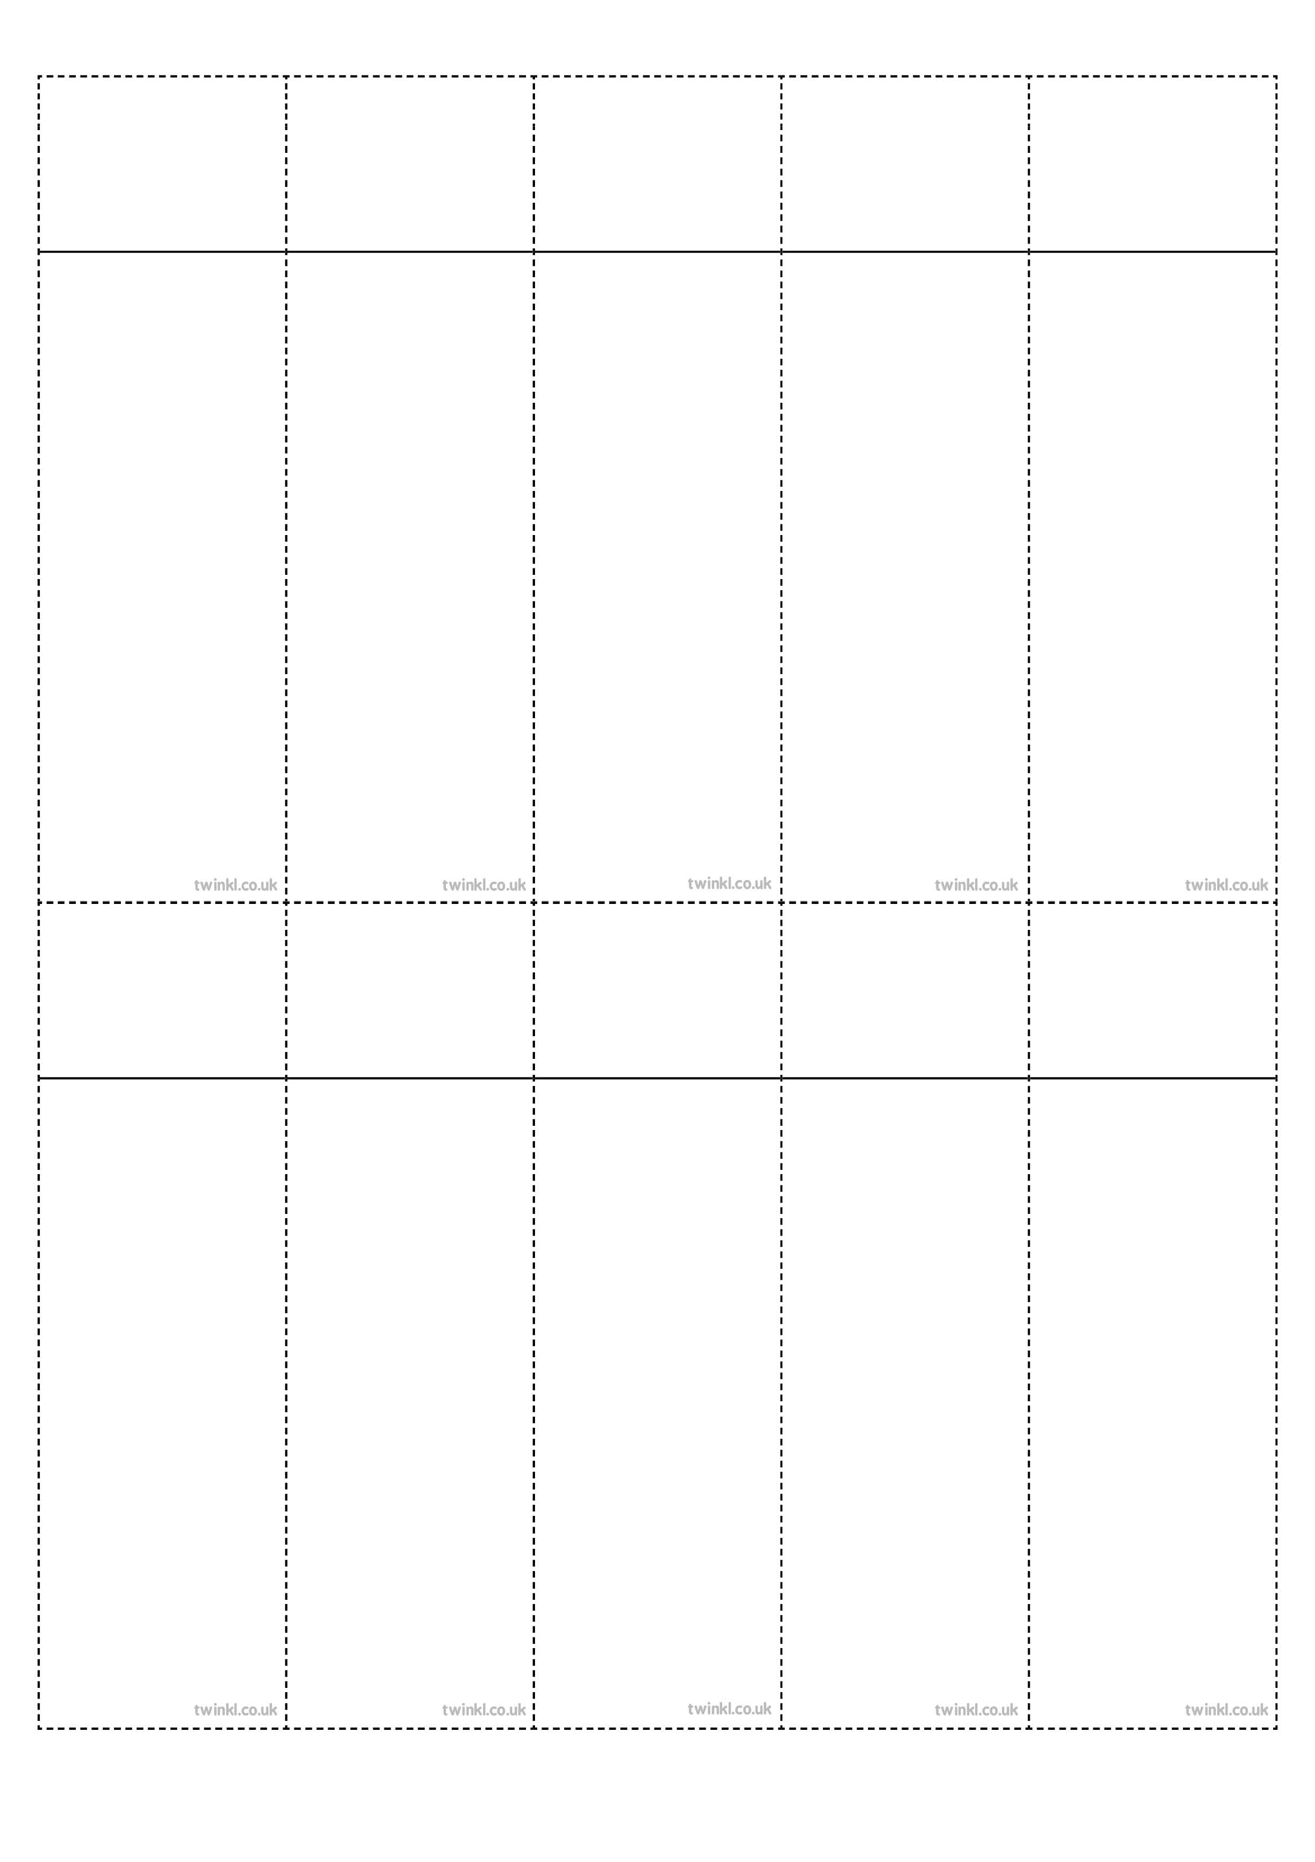
Week 5
Creating negative meaning using prefix dis-
dislike
disobey
discolour
discover
disappear
dishonest
disallow
disbelieve
disapprove
discontinue
Week 5
Creating negative meaning using prefix dis-

dislike
disobey
discolour
discover
disappear
dishonest
disallow
disbelieve
disapprove
discontinue

Week 5
Creating negative meaning using prefix dis-

Week 5
Creating negative meaning using prefix dis-

Week 5
Creating negative meaning using prefix dis-

dislike
disobey
discolour
discover
disappear
dishonest
disallow
disbelieve
disapprove
discontinue

dislike
disobey
discolour
discover
disappear
dishonest
disallow
disbelieve
disapprove
discontinue

dislike
disobey
discolour
discover
disappear
dishonest
disallow
disbelieve
disapprove
discontinue

Week 5
Creating negative meaning using prefix dis-

Week 5
Creating negative meaning using prefix dis-

Week 5
Creating negative meaning using prefix dis-

Week 5
Creating negative meaning using prefix dis-

Week 5
Creating negative meaning using prefix dis-

dislike
disobey
discolour
discover
disappear
dishonest
disallow
disbelieve
disapprove
discontinue

dislike
disobey
discolour
discover
disappear
dishonest
disallow
disbelieve
disapprove
discontinue

dislike
disobey
discolour
discover
disappear
dishonest
disallow
disbelieve
disapprove
discontinue

dislike
disobey
discolour
discover
disappear
dishonest
disallow
disbelieve
disapprove
discontinue

dislike
disobey
discolour
discover
disappear
dishonest
disallow
disbelieve
disapprove
discontinue

