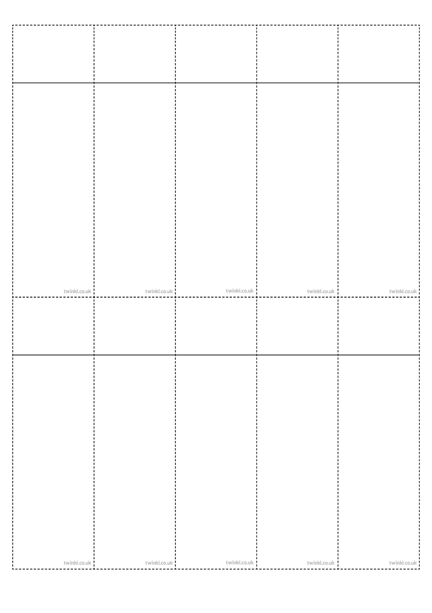
Week 6
Words with a /k/ sound spelt with ‘ch’
scheme
chorus
echo
character
ache
chaos
stomach
chemistry
orchestra
technology
Week 6
Words with a /k/ sound spelt with ‘ch’
scheme
chorus
echo
character
ache
chaos
stomach
chemistry
orchestra
technology
Week 6
Words with a /k/ sound spelt with ‘ch’
scheme
chorus
echo
character
ache
chaos
stomach
chemistry
orchestra
technology
Week 6
Words with a /k/ sound spelt with ‘ch’
scheme
chorus
echo
character
ache
chaos
stomach
chemistry
orchestra
technology
Week 6
Words with a /k/ sound spelt with ‘ch’
scheme
chorus
echo
character
ache
chaos
stomach
chemistry
orchestra
technology
Week 6
Words with a /k/ sound spelt with ‘ch’
scheme
chorus
echo
character
ache
chaos
stomach
chemistry
orchestra
technology
Week 6
Words with a /k/ sound spelt with ‘ch’
scheme
chorus
echo
character
ache
chaos
stomach
chemistry
orchestra
technology
Week 6
Words with a /k/ sound spelt with ‘ch’
scheme
chorus
echo
character
ache
chaos
stomach
chemistry
orchestra
technology
Week 6
Words with a /k/ sound spelt with ‘ch’
scheme
chorus
echo
character
ache
chaos
stomach
chemistry
orchestra
technology
Week 6
Words with a /k/ sound spelt with ‘ch’
scheme
chorus
echo
character
ache
chaos
stomach
chemistry
orchestra
technology

