Science Week - Wednesday 24th February
Reading and Phonics  Listen to a space themed online story, Aliens Love Underpants, Roaring Rockets and Whatever Next? Which is your favourite? Why?  Play ‘I Spy in Space’. ‘I spy, with my little eye, something beginning with t’.  CHALLENGE: You can include these sounds ch, sh, th. | Writing  Write an invitation to the alien to invite them to your very own space party.  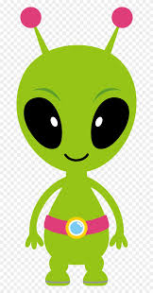
Maths  Work with your child to design a rocket using different 2D shapes. This could be done with 3D shapes if you have spare boxes and resources at home.  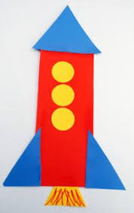 | Learning Project  Make a Textured Planet  Work with your child to create a replica of a planet.  You could papier mache a balloon, or colour, paint or stick bits of materials on to the card to create textured effects.  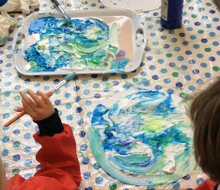  This shaving foam paint technique (see picture) creates a great textured finish when dry. Simply spray shaving foam onto a plate and drop in food colouring or poster paint.

