Science Week - Thursday 25th February
Reading and Phonics  Using the space stories as a starting point, ask your child to make up their own story about space. It could use the same characters or settings as one of the stories you have shared together.  Your child can list things they would see in space that begin with the letters S, P, A,C & E. Then your child can practice writing these letters in space (in the air) using their finger or a pencil. | Writing  Read or watch Alien Tea on Planet Zum-Zee and draw out or write your own menu for an alien. What does an alien eat? Moon-burgers, star biscuits or fruit rockets. Click here for more ideas.  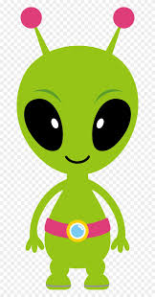
Maths  Ask your child to use Lego, blocks or cardboard boxes to build a tower that is the same height as them, taller than them and shorter than them.  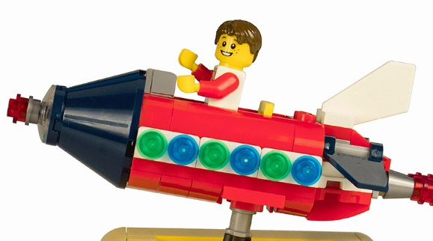 | Learning Project  Phone Home  Create a space phone with your child using items from around the home.  Get them to practise forming numerals correctly to create the buttons.  Make a space phone book to support roleplay.  Ask your child to draw a picture of a different alien on each page and write a phone number for them.

