Science Week - Friday 26th February
Reading and Phonics  Visit Oxford Owl ebooks. Look at the picture book: ‘In the Sky’. Talk about the story together. What is happening on each page?  Play, ‘Pick a Picture’. You can orally sound out the word for your child for them to blend together if they are not yet at the stage of reading independently. | Writing  Ask your child to look up to the sky and down to the ground. Ask them to draw what they can see and have a go at completing the sentence, I can see a..
Maths  Play the online game Let’s Compare.  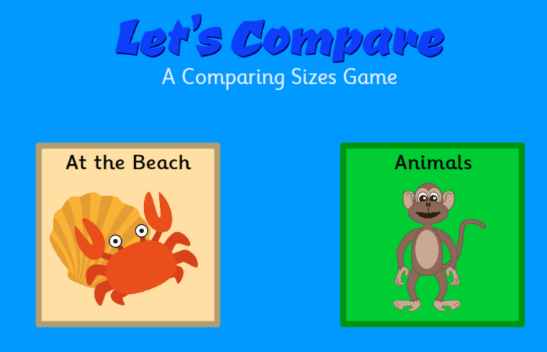 | Learning Project  Support your child to use tin foil to create shiny space suits for their teddies and dolls.  They could have a space-themed teddy bear’s picnic afterwards where they share the biscuits in the next activity!  Make yummy star biscuits to share at the picnic. Click here to find instructions on how to support your child in making simple star biscuits.  They could share them at their space themed teddy bear’s picnic. Share photographs of your space themed picnic on Twitter at #TheLearningProjects.

